Level 2
FURTHER MATHEMATICS
#MathsConf29: Progress your highest attainers towards A-level success with L2FM

Published: Summer 2022

Contents

Contents | Page
Starter questions to try | 4 - 8
Mark schemes | 9 - 12
AQA resources for L2 Further Maths | 13
External resources for L2 Further Maths | 14

Starter questions to try
The below are all taken from Exampro and have been selected to give you a flavour of some of the slightly trickier questions on the specification.

Question 1

Question 18, Paper 1, June 2019

ADEF is a trapezium.
ABCD is a straight line.
BCEF is a square of side cm
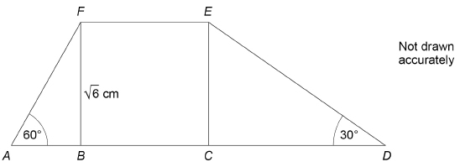
(a) Show that AB = cm
________________________________________________________________
________________________________________________________________
(1 mark)
(b) Show that DE = 2 cm
________________________________________________________________
________________________________________________________________
(1 mark)

(c) Work out the perimeter of the trapezium ADEF.
Give your answer in the form t + w where t and w are integers.
You must show your working.
________________________________________________________________
________________________________________________________________
________________________________________________________________
Answer ______________________________ cm
(3 marks)
Question 2

Question 17, Specimen Paper 2

By multiplying both sides of the equation by x
Solve 2x − 3x = 7x ⁻ for x > 0
Give your answer to 3 significant figures.
You must show your working.
_____________________________________________________________________
_____________________________________________________________________
____________________________________________________________________
_____________________________________________________________________
_____________________________________________________________________
_____________________________________________________________________
_____________________________________________________________________
_____________________________________________________________________
_____________________________________________________________________
_____________________________________________________________________
_____________________________________________________________________
Answer _________________________________________
(4 marks)

Question 3

Question 12, Paper 1, June 2019

A curve has the equation y = x³ + ax² − 7 where a is a constant.
The gradient of the curve when x = 4 is twice the gradient of the curve when x = −1
Work out the value of a.
You must show your working.
_____________________________________________________________________
_____________________________________________________________________
_____________________________________________________________________
_____________________________________________________________________
_____________________________________________________________________
_____________________________________________________________________
_____________________________________________________________________
_____________________________________________________________________
_____________________________________________________________________
_____________________________________________________________________
_____________________________________________________________________
Answer = _________________________________________
(5 marks)

Question 4

Question 11, Specimen Paper 1

A circle, centre C, touches the y-axis at the point (0, 2)
The line y = k intersects the circle at the points (1, k) and (5, k)
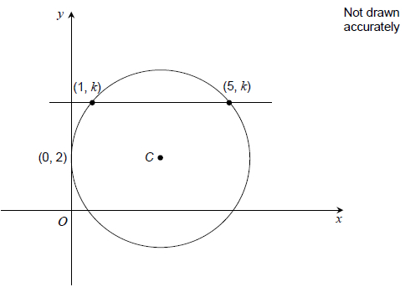
Work out the equation of the circle.
_____________________________________________________________________
_____________________________________________________________________
_____________________________________________________________________
Answer _________________________________________
(3 marks)

Mark schemes

Question 1

Question 18, Paper 1, June 2019

 | Answer | Mark | Comments
(a) | Alternative method 1
 | 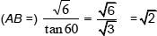 | B1 | oe must see tan60 oe and some evidence of manipulation with oe as well as the final answer to award B1
 | Alternative method 2
 | Use of 1 : 2 : triangle and showing that our triangle is an enlargement scale factor | B1 | oe must see the triangle drawn and labelled or the ratio clearly seen and the scale factor clearly stated

(b) | Alternative method 1
 | 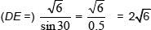 | B1 | oe must see sin30 oe and some evidence of manipulation with 0.5 oe as well as the final answer to award B1
 | Alternative method 2
 | Use of 1 : 2 : triangle and showing that our triangle is an enlargement scale factor | B1 | oe must see the triangle drawn and labelled or the ratio clearly seen and the scale factor clearly stated

(c) | 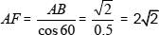  or 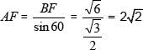  or  so | B1 | oe  allow or for this mark seen on the diagram or clearly shown in working
 | 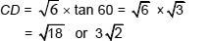  or CD = DE cos 30°  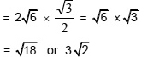  or 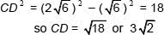 | B1 | oe  allow or or for this mark seen on the diagram or clearly shown in working
 |  | B1dep | dependent on B1, B1 already awarded

Additional Guidance
Condone brackets missed off if recovered
AF and CD could be seen in part (a) or part (b) so could be awarded B1 in part (c) if used correctly

Question 2

Question 17, Specimen Paper 2

 | Answer | Mark | Comments
 | 2x² − 3x = 7 | M1 | at least two terms correct
 | 2x² − 3x − 7 (= 0) | A1 | oe 3-term quadratic equation
 | 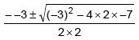  or 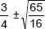 | M1 | oe  correct attempt to solve their 3-term quadratic equation
 | 2.77 | A1 | 2.77 and − 1.27 is A0

Question 3

Question 12, Paper 1, June 2019

 | Answer | Mark | Comments
 | 3x² + 2ax | M1 | allow a derivative with at least one term correct and a term in a  eg 3x² + 2ax + 7 or 3x² + 2a
 | 3(4)² + 2a(4) or 48 + 8a | M1
 | 3(−1)² + 2a(−1) or 3 − 2a | M1
 | 48 + 8a = 2(3 − 2a) | M1dep | oe ft if first M1 earned
 | (a =) −3.5 | A1 | oe

 | Additional Guidance
 | Minimum expected working is to see the correct derivative in the first M mark. If no working seen then no marks can be awarded
 | If the word "twice" is interpreted the wrong way round ie equation becomes  2(48 + 8a) = 3 − 2a this gives an answer of a = −5 or −5.1666... | M1, A1, A1, M0, A0

Question 4

Question 11, Specimen Paper 1

 | Answer | Mark | Comments
 | 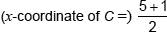 or 3  or 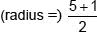 or 3 | M1 | may be implied
 | (y-coordinate of C =) 2 | M1 | may be implied
 | (x − 3)² + (y − 2)² = 9 | A1 | allow (x − 3)² + (y − 2)² = 3²

AQA resources for Level 2 Further Mathematics

AQA Overview page
aqa.org.uk/subjects/mathematics/aqa-certificate/further-mathematics-8365/introduction

Specification document
aqa.org.uk/subjects/mathematics/aqa-certificate/further-mathematics-8365/changes-for-2022

Resources for the current specification including specimen, practice and past papers
allaboutmaths.aqa.org.uk/1644

AQA student resources – worksheets for most topics
allaboutmaths.aqa.org.uk/1649

Exampro for L2 Further Maths – currently free for 2022
exampro.co.uk/mathematics/#1628868660003-cfee5949-a590

Legacy resources – very similar specification so still useful including past papers
allaboutmaths.aqa.org.uk/level2FM

Route maps and teaching guidance
allaboutmaths.aqa.org.uk/1647
allaboutmaths.aqa.org.uk/1648

External resources for Level 2 Further Mathematics

Corbett Maths – lots of videos and worksheets
corbettmaths.com/more/further-maths/

Increasingly difficult questions – nice resource for extension questions. Covers GCSE also
taylorda01.weebly.com/increasingly-difficult-questions.html#l2fm

Mr Barton – selection of worksheets and PowerPoints
mrbartonmaths.com/students/aqa-level-2-certificate-in-further-mathematics/

Advanced Maths Support Program (government funded) also produces resources. Teacher access is free for schools who register
amsp.org.uk/teachers/11-16-maths/resources

Notes

Contact us
Our friendly team will be happy to support you between 8am and 5pm, Monday to Friday.

Tel: 0161 957 3852
Email: maths@aqa.org.uk
Twitter: @AQAMaths

aqa.org.uk

