GCSE

MATHEMATICS

#MathsConf29: How we make exams better and how that may help your teaching

# Resource booklet

Published: Summer 2022

### Contents

|  |  |
| --- | --- |
| Contents | Page |
| What can we learn from writing questions? (Speed/time question) | 4 |
| Making a better question: Example (sectors question) | 6 |
| What can we learn from marking? Exercise 1 (area question) | 8 - 15 |
| What can we learn from marking? Exercise 2 (mean question) | 16 - 23 |

### What can we learn from writing questions?

### What are we testing?

#### Practice paper 2016

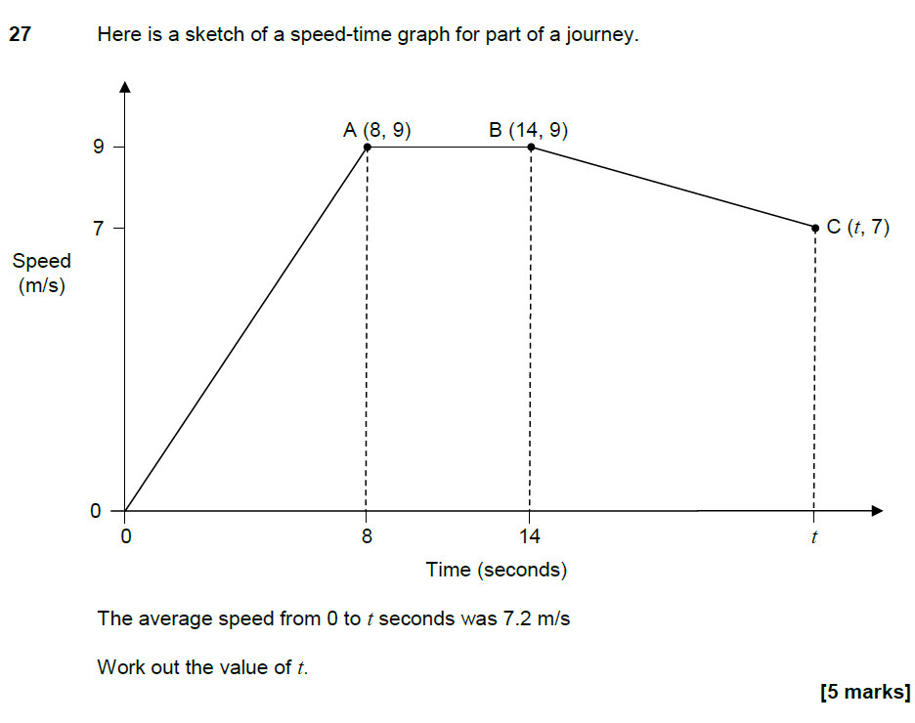

#### Notes (Write your answer here):

#### Notes (Write your answer here):

### Making a better question

### Revisiting unsuccessful questions

#### GCSE Maths, Q16, Paper 3H, June 2019

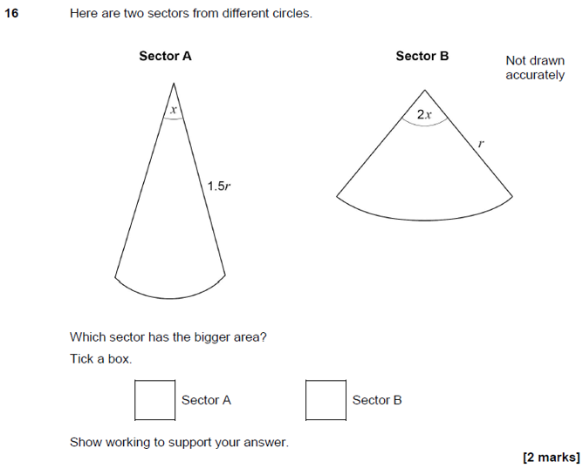

Content reference

G18: Calculate arc lengths, angles and areas of sectors of circles.

N8: Calculate exactly with multiples of π

Assessment objectives

AO3.1b: Translate problems in mathematical contexts into a series of mathematical processes.

AO3.3: Interpret results in the context of the given problem.

Mark scheme

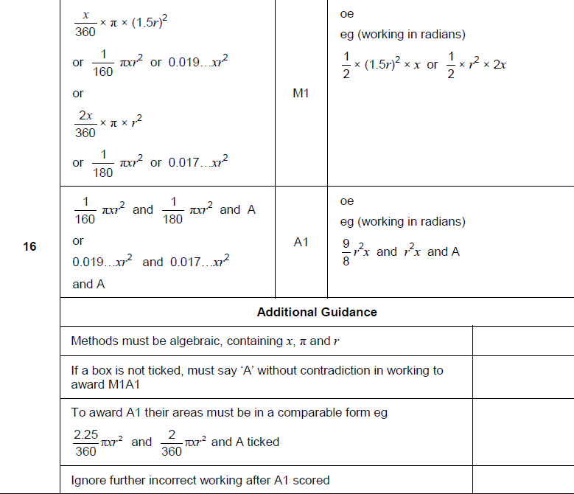

## What can we learn from marking?

### A fair and consistent mark scheme: Exercise 1

#### GCSE Maths, 8300/1H, Q9, June 2019

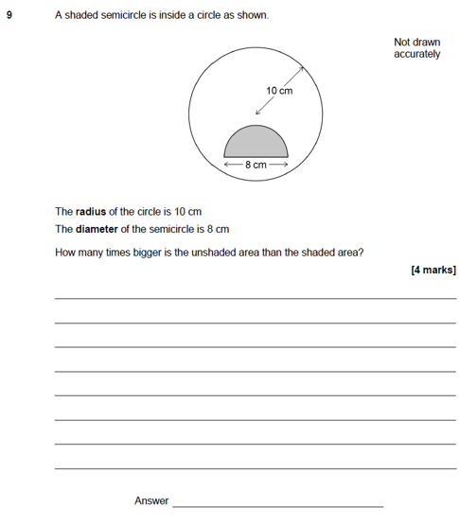

Example 1

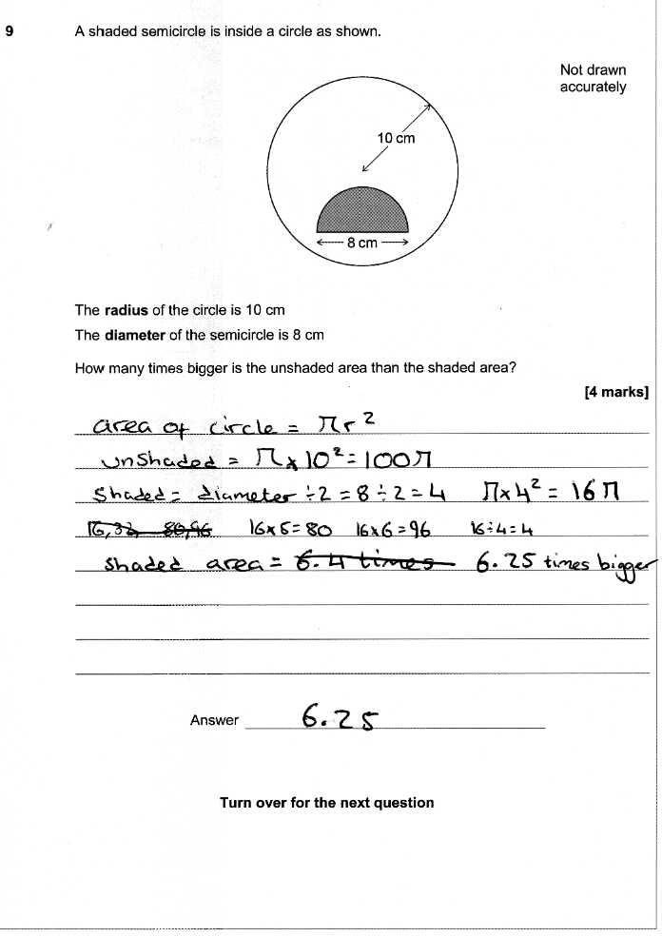

Example 2

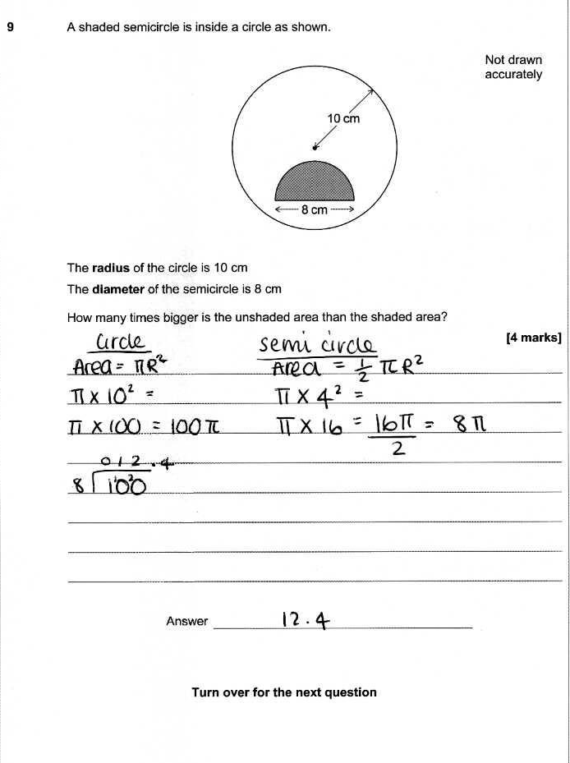

Example 3

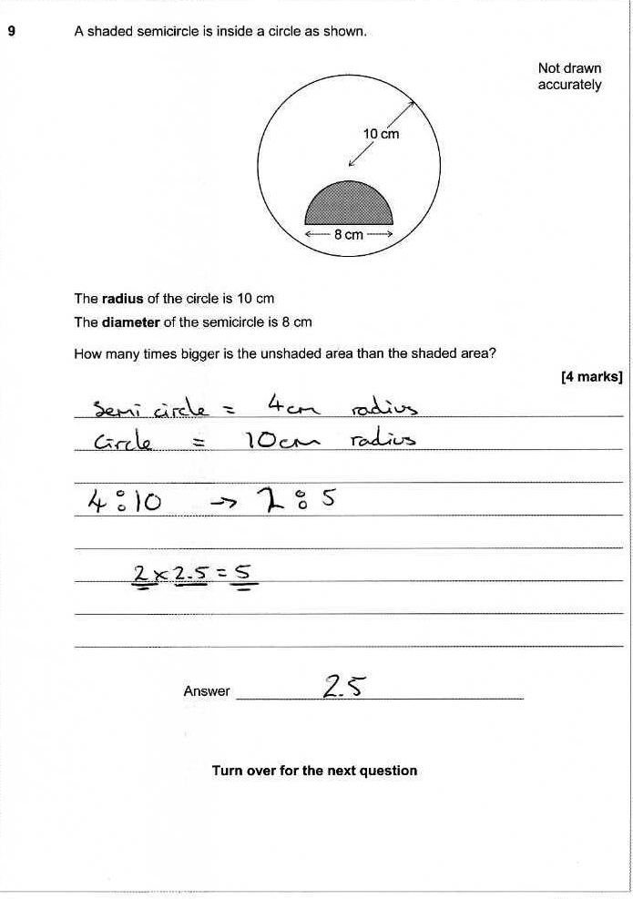

Example 4

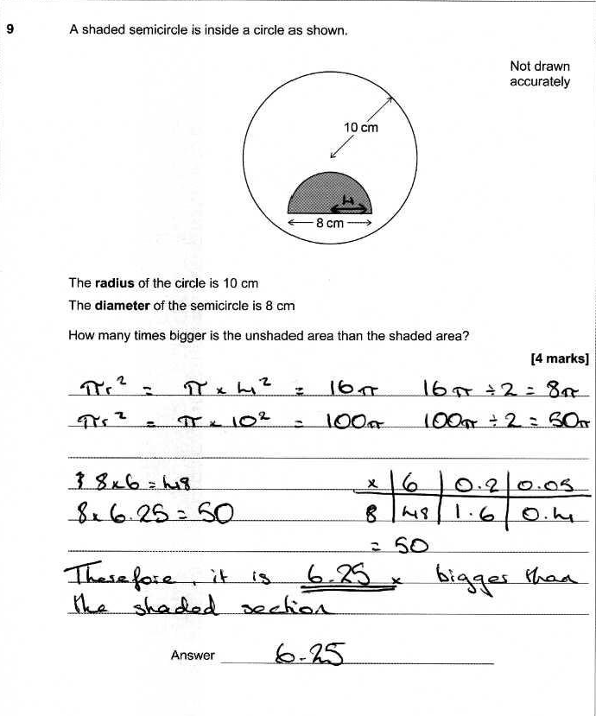

Example 5



|  |  |  |  |
| --- | --- | --- | --- |
| **9** | **Method 1** | | |
| **Answer** | **Mark** | **Comments** |
|  | M1 |  |
|  | M1 |  |
|  | M1 |  |
|  | A1 |  |

|  |  |  |  |
| --- | --- | --- | --- |
| **9** | **Method 2** | | |
| **Answer** | **Mark** | **Comments** |
|  | M1 |  |
|  | M1 |  |
|  | M1 |  |
|  | A1 |  |

What can we learn from marking?

### A fair and consistent mark scheme: Exercise 2

### GCSE Maths, 8300/3H, Q11, June 2019



Example 1

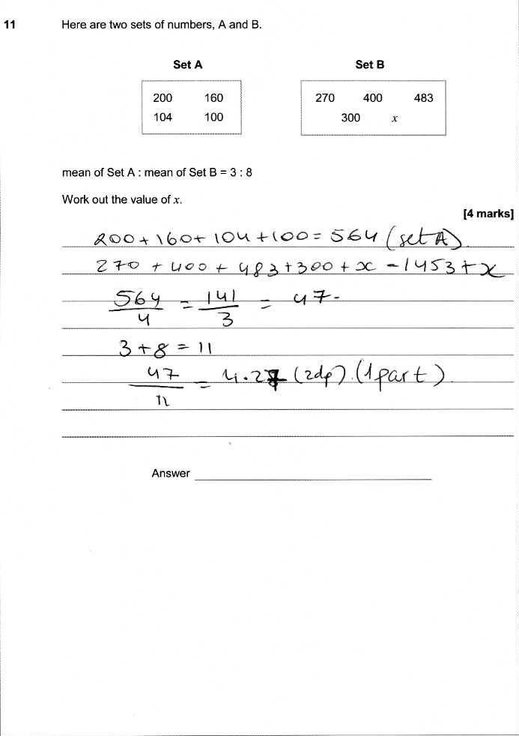

Example 2

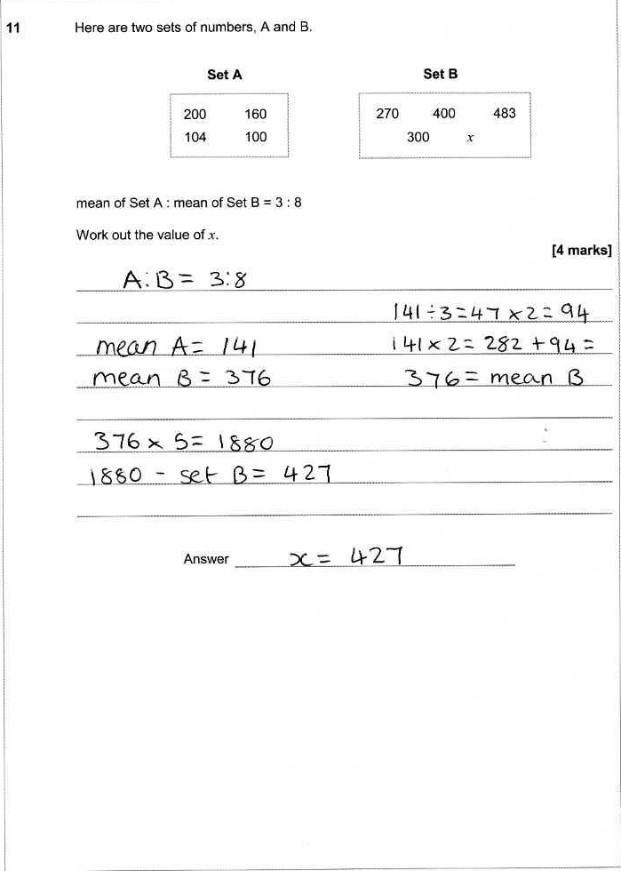

Example 3

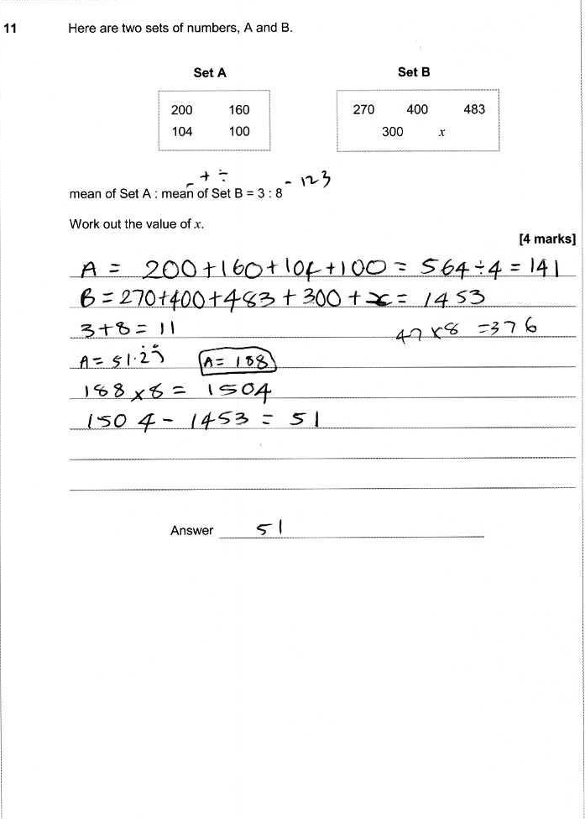

Example 4

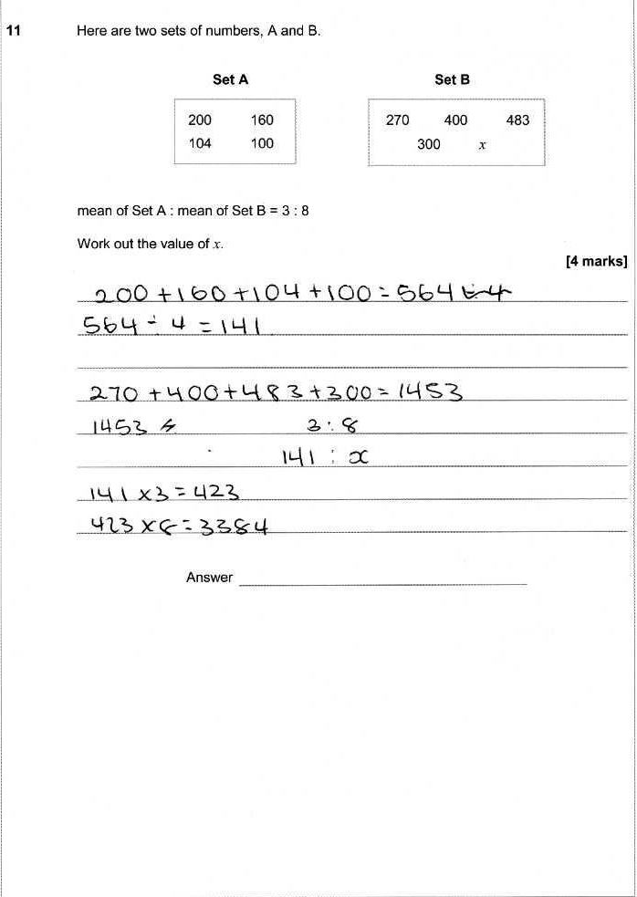

Example 5

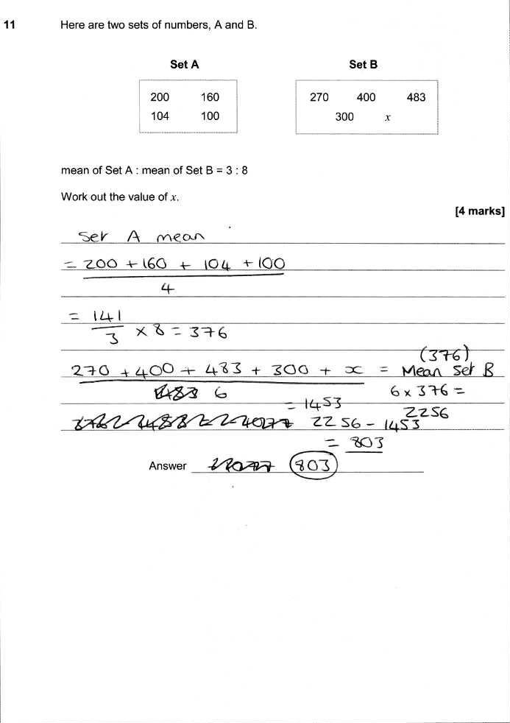

|  |  |  |  |
| --- | --- | --- | --- |
| **11** | **Method 1** | | |
| **Answer** | **Mark** | **Comments** |
|  | M1 |  |
|  | M1 |  |
|  | M1 |  |
|  | A1 |  |

|  |  |  |  |
| --- | --- | --- | --- |
| **11** | **Method 2** | | |
| **Answer** | **Mark** | **Comments** |
|  | M1 |  |
|  | M1 |  |
|  | M1 |  |
|  | A1 |  |

Notes

Contact us  
  
Our friendly team will be happy to support you between 8am and 5pm, Monday to Friday.

Tel: 0161 957 3852

Email: maths@aqa.org.uk

Twitter: @AQAMaths

[aqa.org.uk](https://www.aqa.org.uk/)