ASE 2023: Reinvigorating the learning experience during practical lessons

Spring 2023
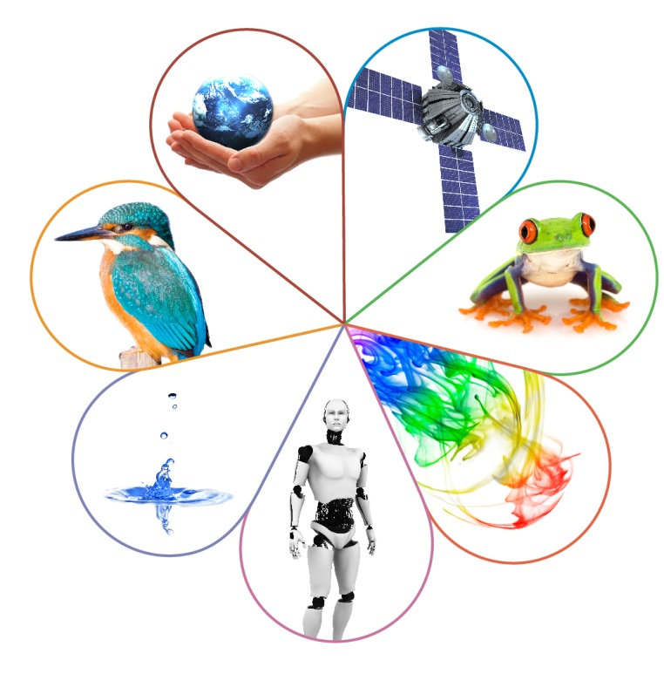

Contents | Page
Practical skills assessment in relation to AO1 | 4
Practical skills assessment in relation to AO2 | 5
Practical skills assessment in relation to AO3 | 7
What is Brandon’s Matrix? | 13
Applying Brandon’s Matrix to required practicals | 14

Practical skills assessment in
relation to AO1

AO1 practical questions require students to show understanding of scientific techniques, skills, apparatus and materials and awareness of safety aspects. For example:
- describe procedures stated in the specification
- identify types of variable in a required practical
- identify a zero error from an image with a reading
- draw or label common practical apparatus correctly.

AO1 examples from 2022 assessments
Here are a couple of examples from the summer 2022 Combined Science papers; first clearly in context of required practical – osmosis.

The second one, although the context is not necessarily one students know, use of a quadrat is one of the RPAs (Field studies).

Both were questions that students struggled to answer well.

Example 1: 2022 Combined Science Synergy 1F Question 10.1
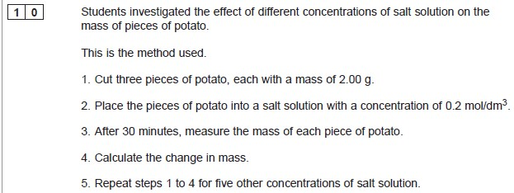
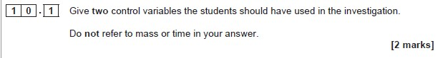

Example 2: 2022 Combined Science Trilogy Biology 2F Question 2.1
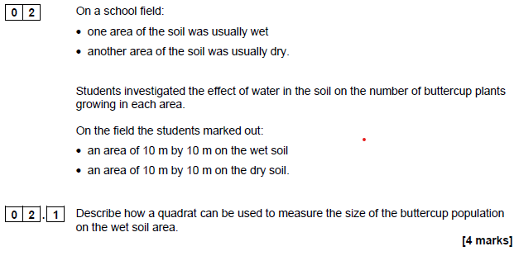

Practical skills assessment in relation to AO2

Practical skills are very likely to be assessed in the context of a practical students haven’t seen before – it may be something totally new, or a variant on what they may have done in a required practical. They need to use the skills and understanding they should have gained by doing practical work to do the things that are listed here.

Students need to use the skills and understanding they have gained doing practical work to, for example:
- identify control variables in an unfamiliar practical where the variables are given in the question
- identify dependent and independent variables in an unfamiliar practical
- make a prediction or a hypothesis based on information in the specification
- take readings from scales on apparatus
- use diagrams to communicate experimental methods
- plot graphs and carry out calculations.

AO2 examples from 2022 assessments

Example 3: 2022 Combined Science Trilogy Biology 2F Question 2.4

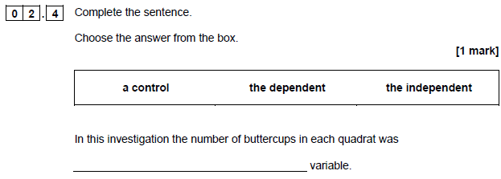

Same context as Example 2. Very low demand understanding of the variables, which are given in the method. It’s likely to be an unfamiliar context. Students need to identify that the number of buttercups is the dependent variable.

Example 4: 2022 Combined Science Trilogy Chemistry 1F Question 5.1
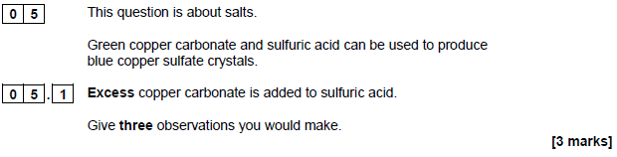
The chemistry example is asking students to predict what they would see in this reaction; one they might not have done in a practical session. NB they have to prepare a salt but not necessarily this one.

Example 5: 2022 Combined Science Synergy 4F Question 10.1
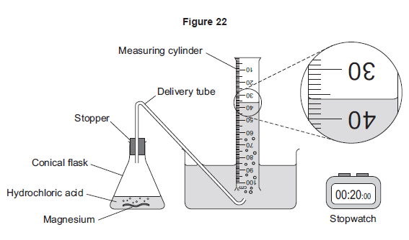
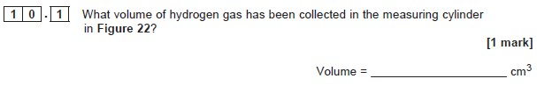

A few marks in each series test ability to read a scale; many students do struggle if the scale is not given in an obvious way eg like this one. They can usually manage to read something like a thermometer, but as soon as something slightly unusual appears they are unable to do to; taking readings on a burette also seem to cause problems.

Practical skills assessment in relation to AO3

Practical skills are very likely to be assessed in the context of a practical students haven’t seen before – it may be something totally new, or a variant on what they may have done in a required practical. They need to use the skills and understanding they should have gained by doing practical work to do the things that are listed here.

- In the context of AO3 questions will take an analytical form such as suggesting limitations of a particular method.
- Students will also be expected to be able to adapt, modify and enhance experimental procedures, but not to develop their own procedures.
- ‘Experimental procedures’ encompasses but is broader than the core practical activities.
- For example:
  - identify control variables in an unfamiliar practical
  - identify anomalous results
  - give reasons for anomalous results
  - identify specific sources of error
  - consider the validity of methods in justifying conclusions
  - design/plan a practical procedure to test an idea, answer a question or solve a problem for a non-required practical.

AO3 examples from 2022 assessments

Example 6: 2022 Combined Science Trilogy Biology 2F Question 2.7

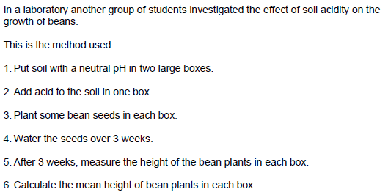

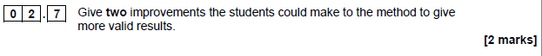
Students need to look at the method given and suggest improvements; unfamiliar practical.

Example 7: 2022 Combined Science Synergy 4F Question 10.2

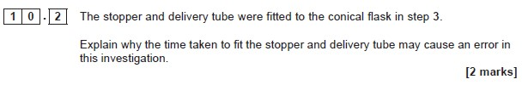

This question is based in the context of a rate of reaction practical, but asking for understanding of why an error might be caused.

Example 8: 2022 Combined Science Synergy 2H Question 5.3

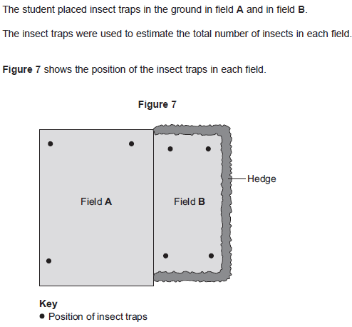
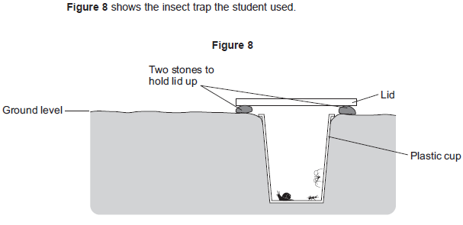
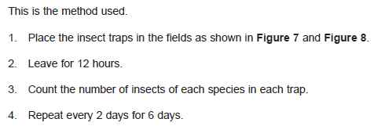
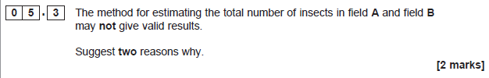

Testing understanding why a particular method is not valid.

Example 9: 2022 Combined Science Synergy 4F Question 5.3

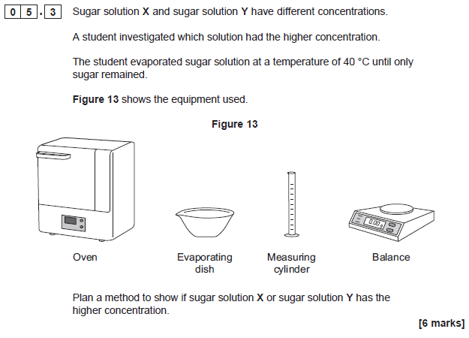

Suggesting a method to solve a problem.

Example 10: 2022 Combined Science Synergy 4F Question 4.3 and 4.4

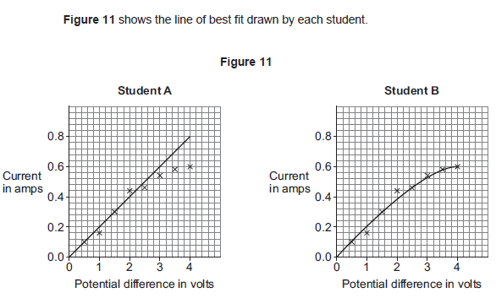

Understanding about anomalous results and plotting lines of best fit.

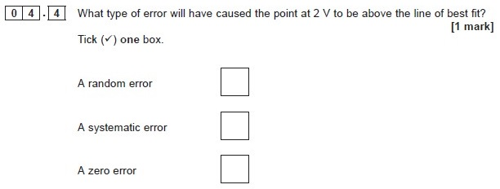
This question is about being able to identify the type of error that causes an anomalous result.

What is Brandon’s Matrix?
A simplified 2 × 2 matrix based on two questions:
- Are we testing a hypothesis, or making observations and measuring parameters?
- Are we changing (manipulating) variables, or not?
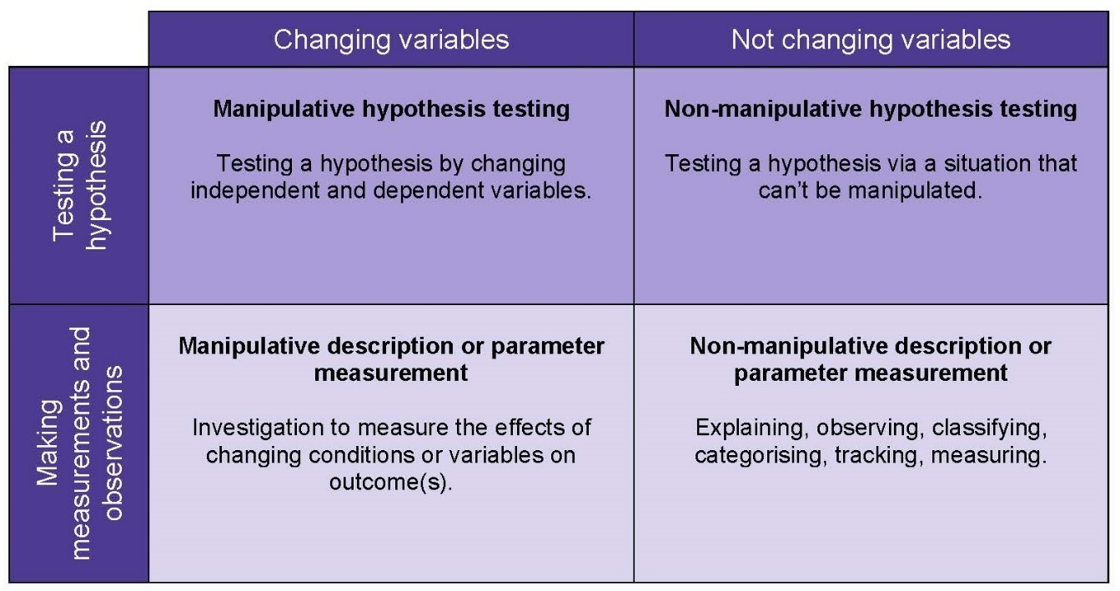

The importance of the matrix is that it challenges the traditional linear model of the scientific method in the science curriculum. A fairly typical depiction in school of how science is done involves the so-called ‘scientific method’, which is described as a process through which scientists produce robust evidence by applying procedures such as experimentation and observation. According to this model, scientists begin with a question they want to answer. They then design an experiment and, by carefully tracing independent and dependent variables, they produce findings that help them answer the question. However, such a stepwise and linear description of the scientific method is simplistic and hardly a realistic representation of how scientists actually do science. Rather, scientists engage in a wide array of methods some of which include hypothesis testing, and some other approaches including those where there is no manipulation of variables (Erduran & Dagher, 2014).

A contemporary example about Brandon’s matrix involves the Covid-19 pandemic (Erduran, Childs & Baird, 2020). Scientists collect data on how the virus might be influencing a patient’s breathing over a period of time. Such observation is simply based on the recording of parameters where there is no manipulation of variables in the sense of an experimental design. Sometimes the data might be subjected to hypothesis testing about the correlation between incubation period and extent of lung disease, but without an experiment resulting in non-manipulative hypothesis testing. Scientists may conduct randomised control trials in which a drug could be treated as a variable in interventions that also include control groups to test the placebo effect. All of these different approaches are used in science, and there is no one single method but rather a diversity of scientific methods.

Extracted from the Project Calibrate website Project Information | Project Calibrate (ox.ac.uk)Erduran, S. Dagher, Z. R. (2014) Reconceptualizing the Nature of Science for Science Education: Scientific Knowledge, Practices and Other Family Categories, Springer Netherlands
Erduran, S., Childs, A. & Baird, J. A. (2020). Practical science and pandemics [Blog post]. Retrieved from https://www.bera.ac.uk/blog/practical-science-and-pandemics, April 20th.

Applying Brandon’s Matrix to Required Practicals

Biology RPA7

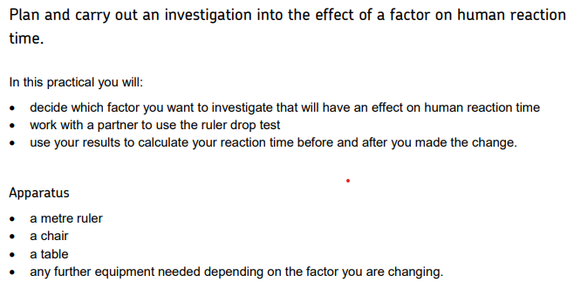
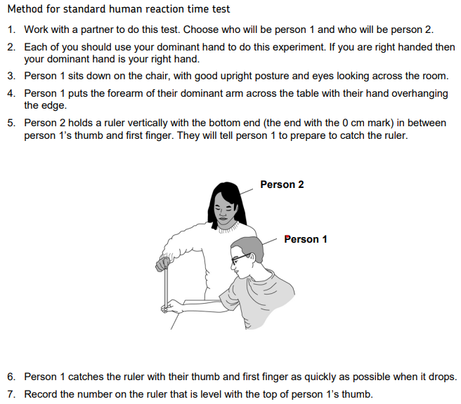
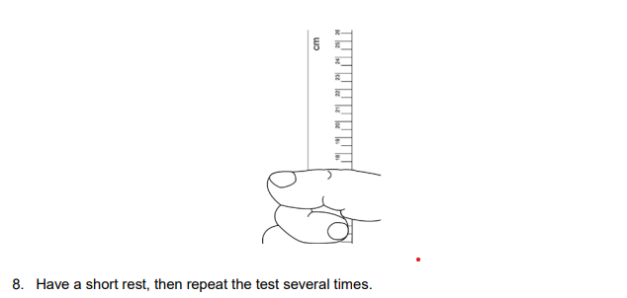
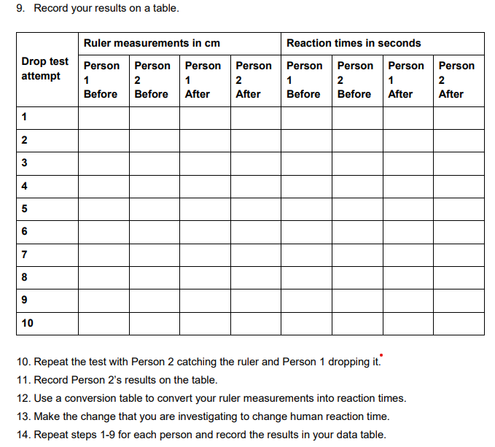

Chemistry RPA3

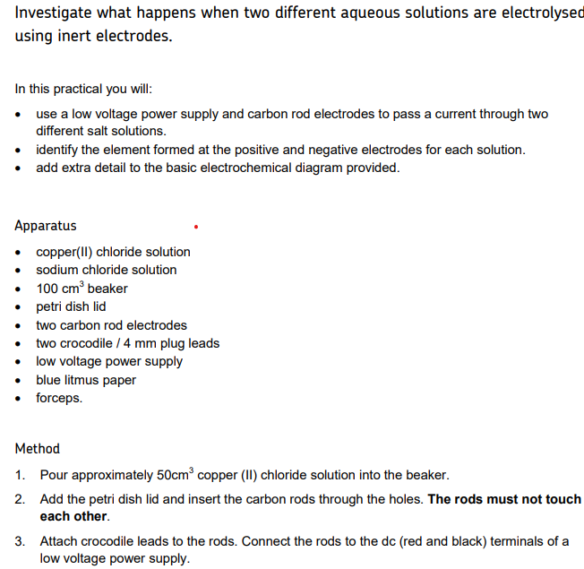

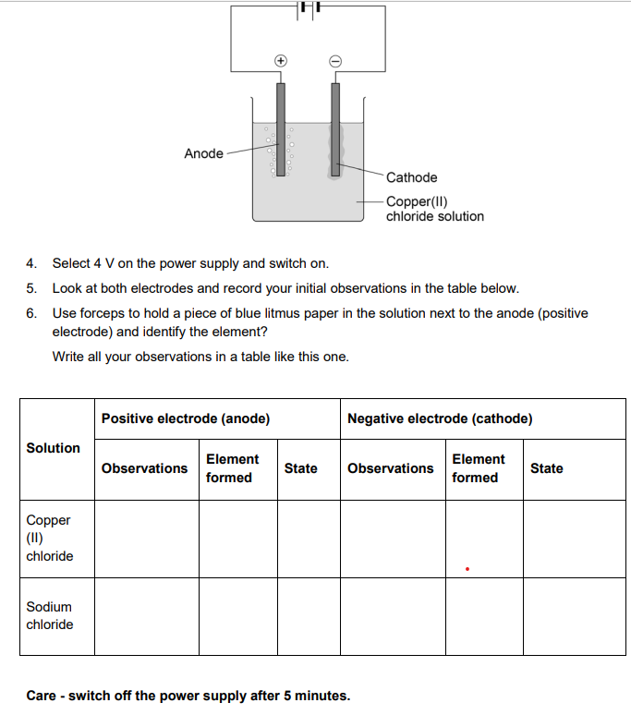
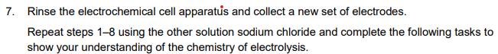

Physics RPA3

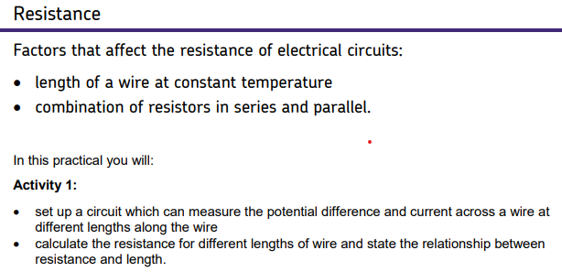
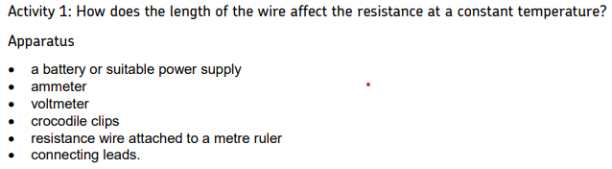
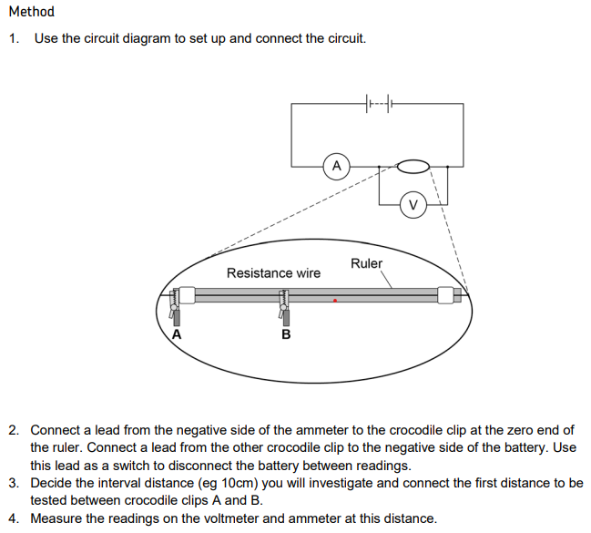
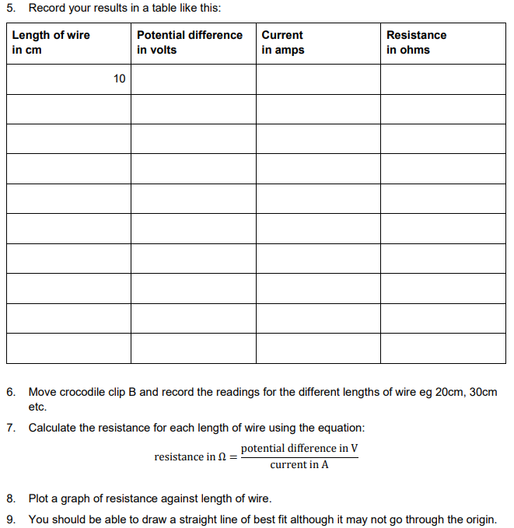

Contact us
Our friendly team will be happy to support you between 8am and 5pm, Monday to Friday.

Tel: 01483 477 756
Email: gcsescience@aqa.org.uk alevelscience@aqa.org.uk
Twitter: @AQA

aqa.org.uk

