ASE 2023: ETC GCSE Science
Support booklet and further information

Spring 2023

Contents | Page
Assessment objectives | 4
Structure of an exam question | 6
Types of questions and common errors | 9
Summary information on assessing physics equations | 20
Graphs | 28
Extended response | 33
Command words | 38
Working scientifically | 40
Elements covered in practical questions | 44

Assessment objectives: Trilogy C2H 2018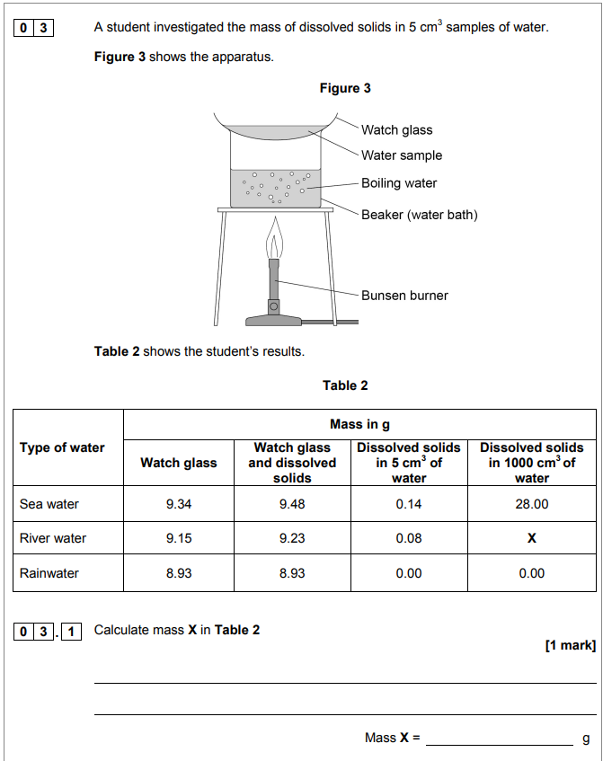
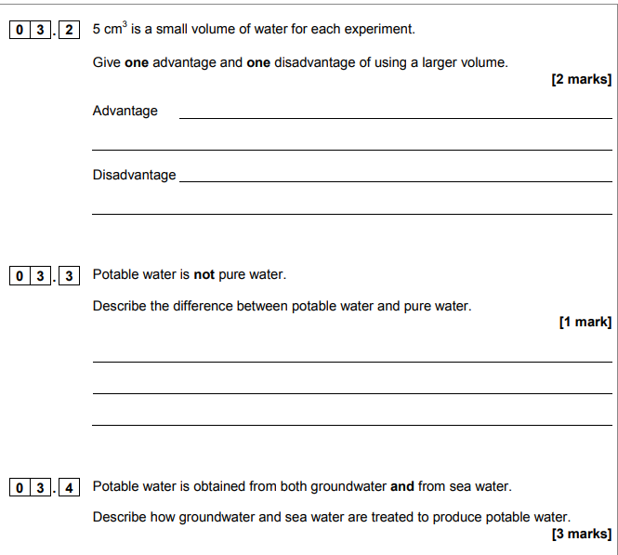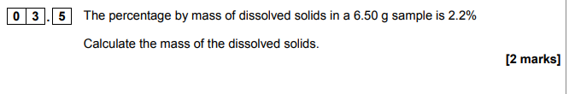

Structure of an exam question: Trilogy P2 2018 standard demand

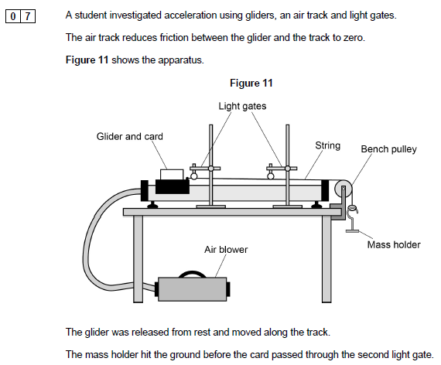

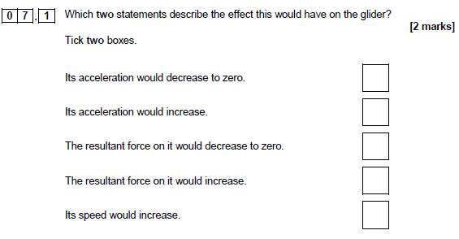

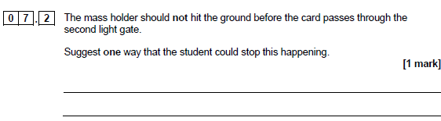
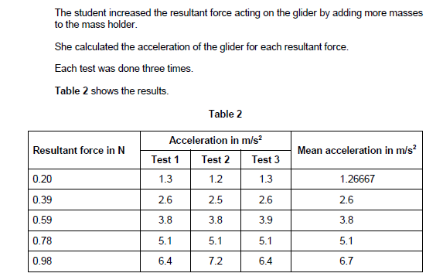
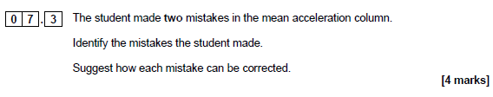
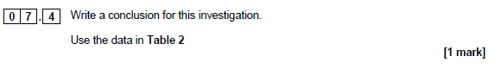
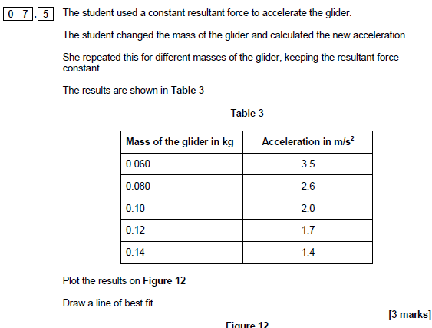

Graph paper given with scales and axis labelled
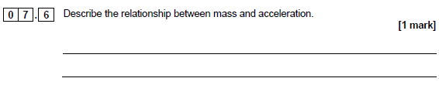
.

Types of questions and common
errors

Multiple-choice questions

Ticking too many boxes, or not enough.

Short-answer questions

Being clear about what they are referring to

Example 1

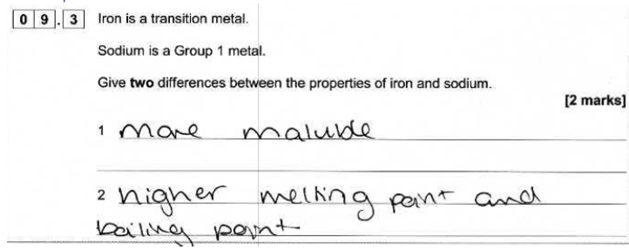
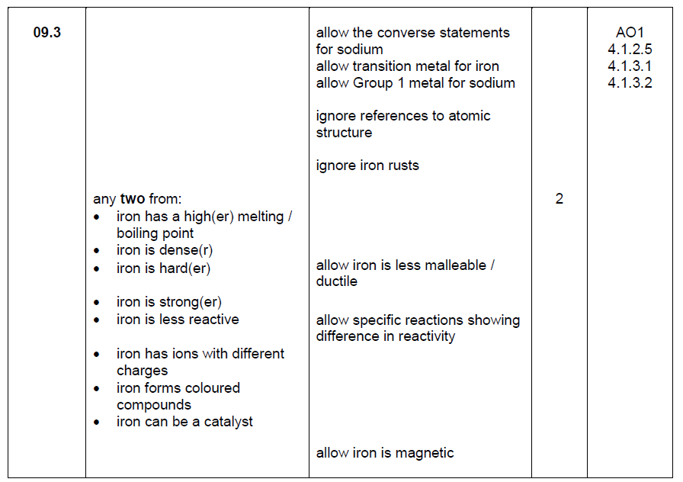

Being vague or not answering the question fully

Example 2

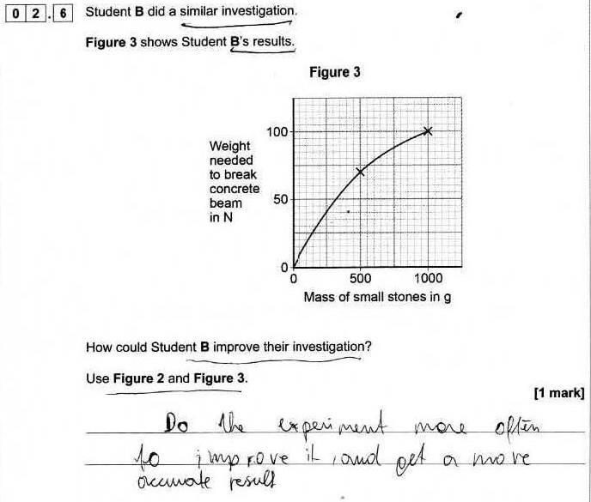

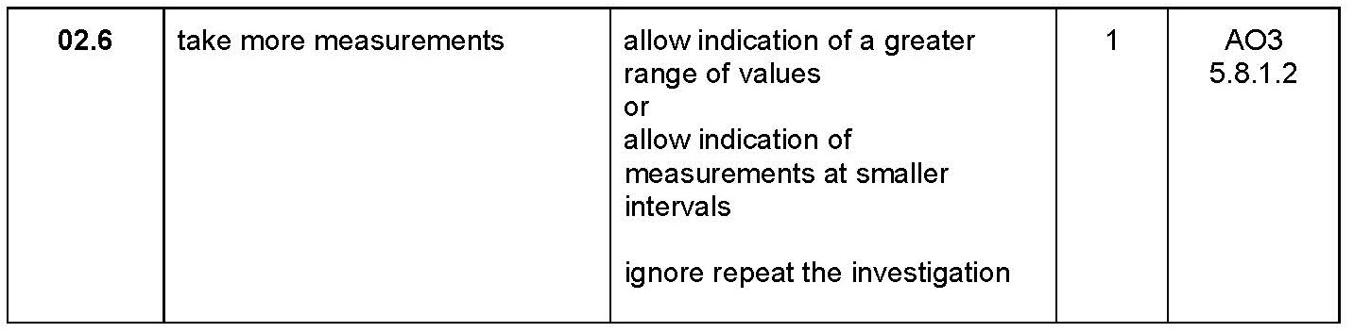

Example 3

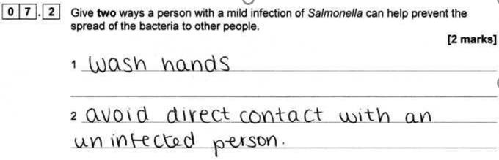
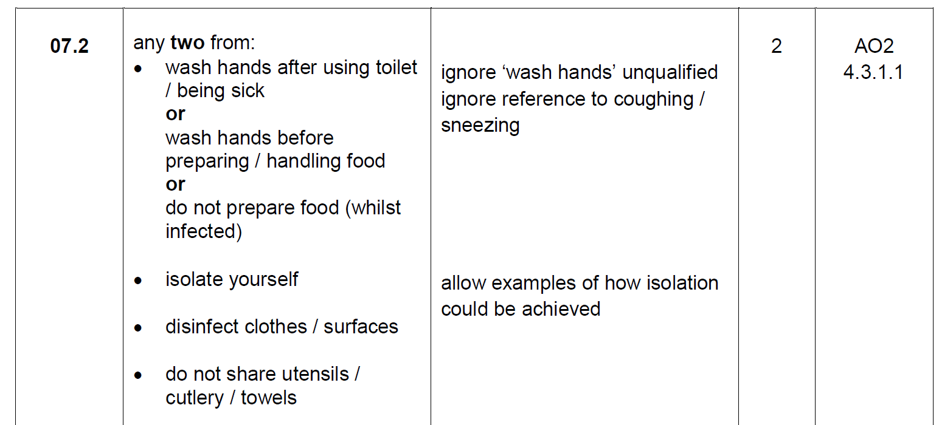

Repeating unnecessary information

Example 4
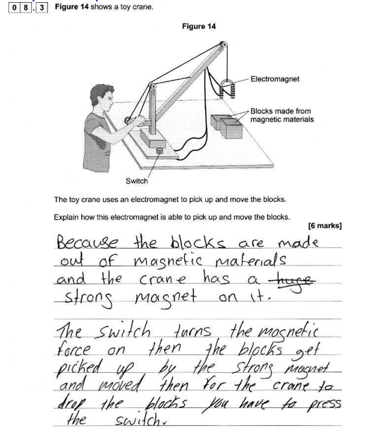
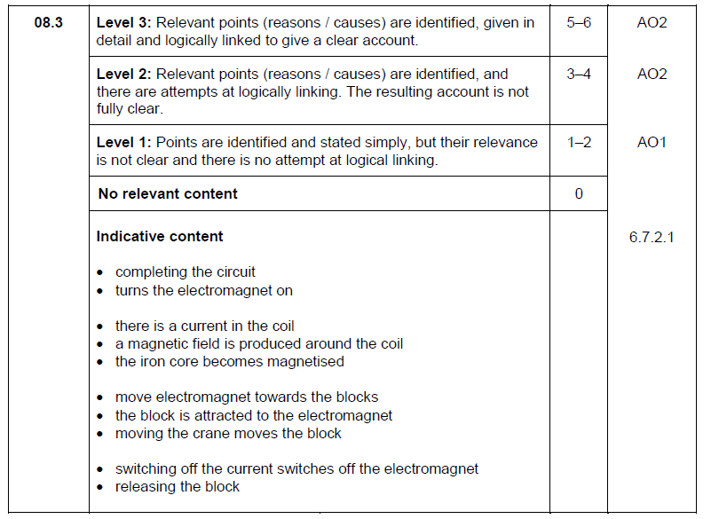

Not explaining fully

Example 5
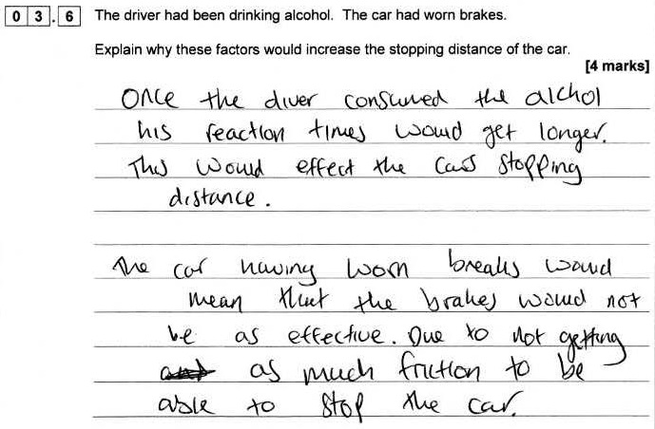

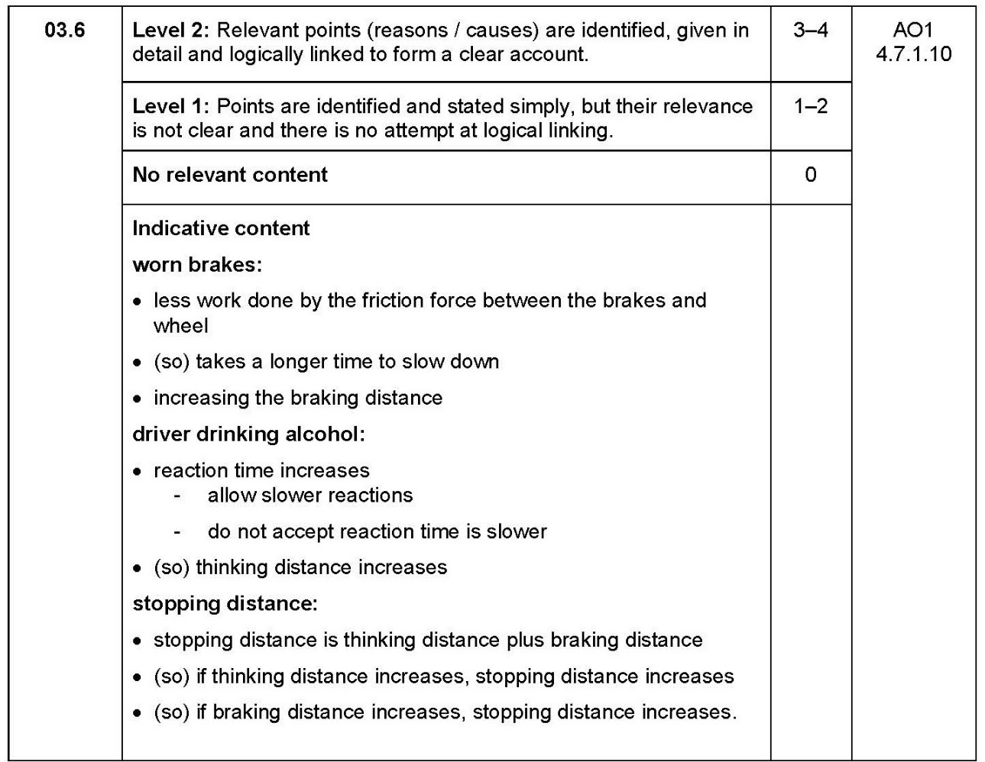

Putting a right and wrong answer

Example 6

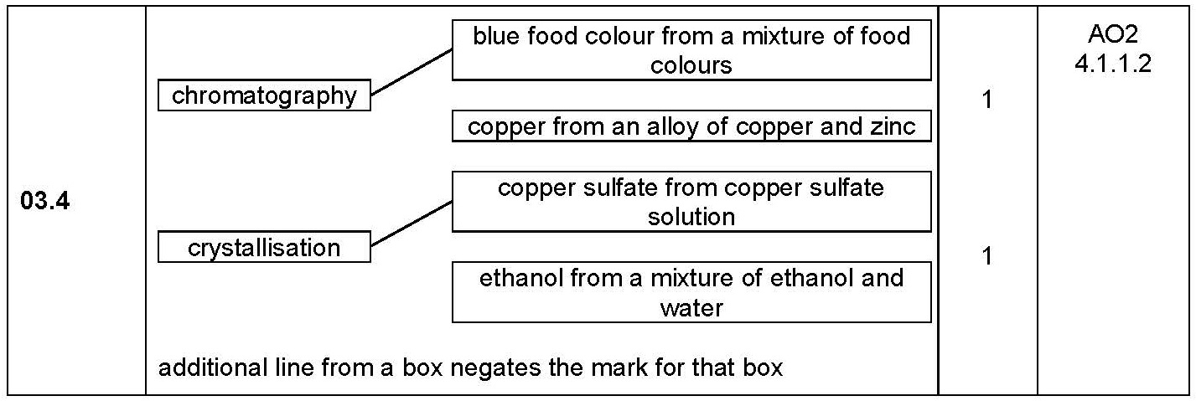

General principles of marking calculations

Example 7
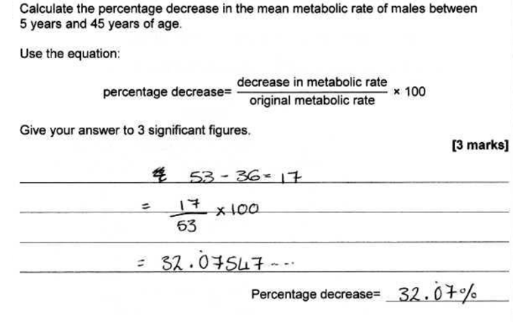
Repeat symbol

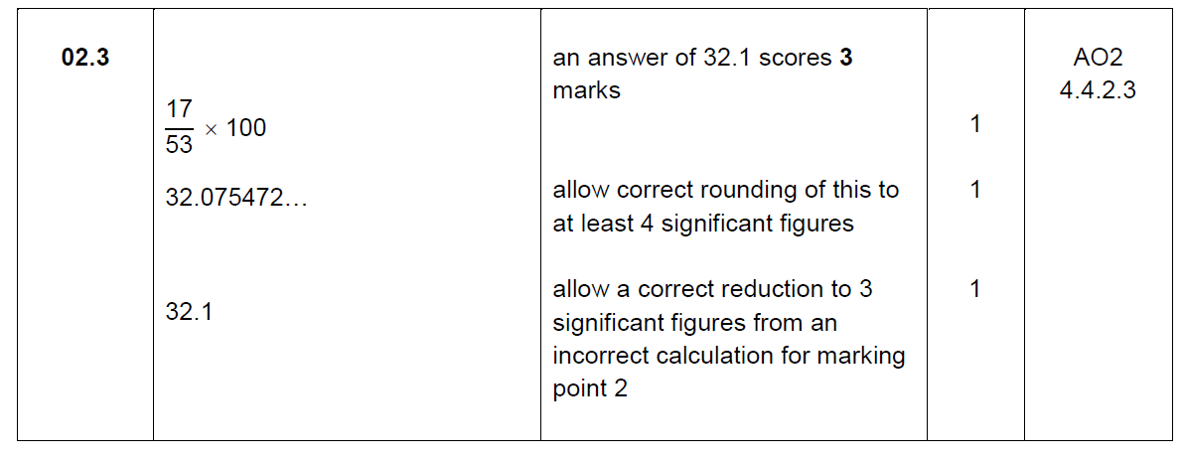

Example 8
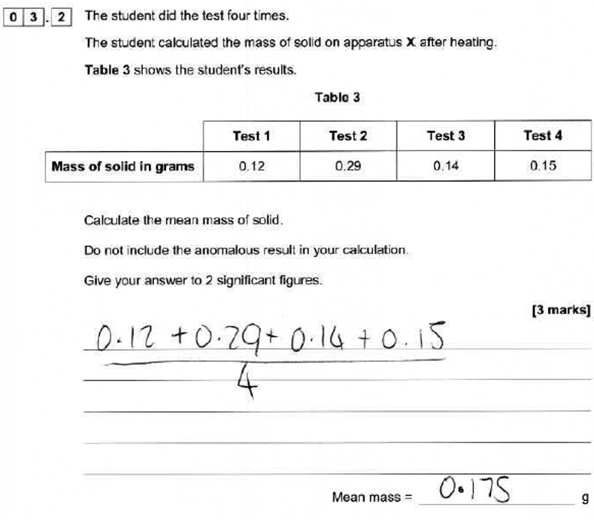
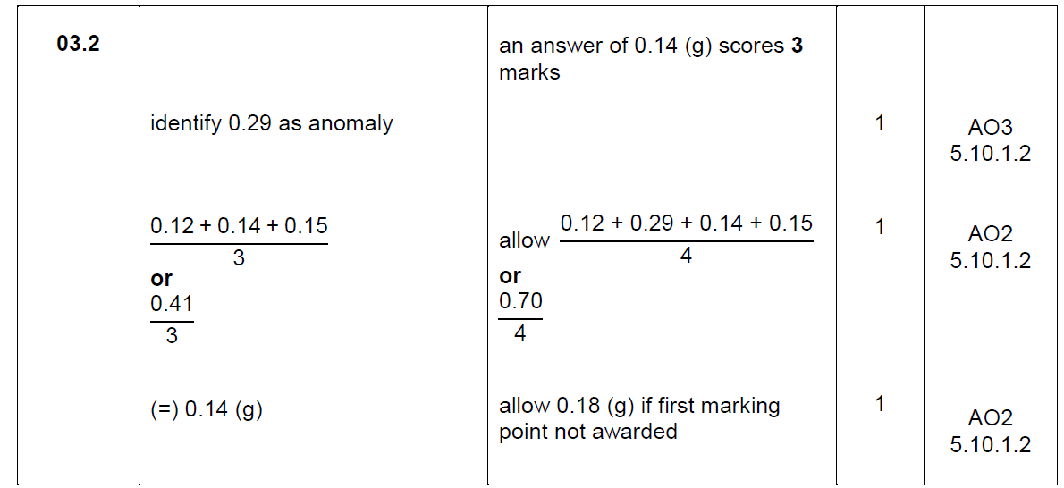

Example 9

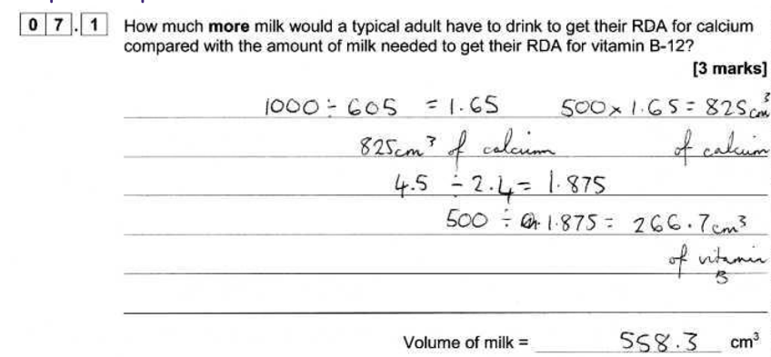

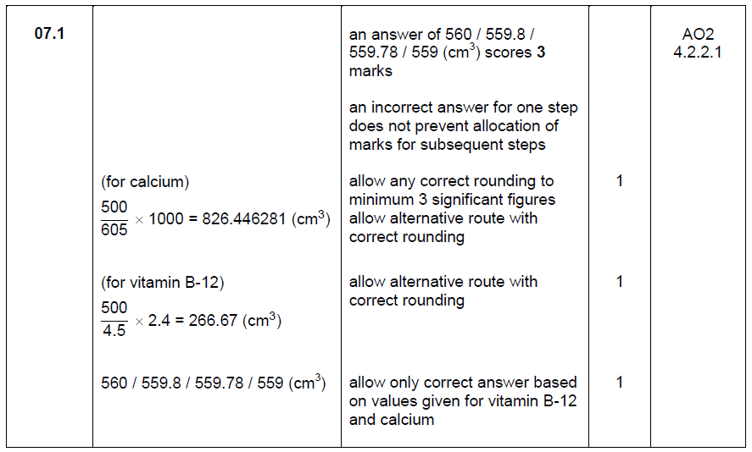

Summary information on
assessing physics equations

- 23 Physics equations that students need to know and be able to apply (21 in Combined Science).
- 12 further Physics equations (7 in Combined Science) that students must be able to select from a list and apply. Students will be given the prompt ‘Use the correct equation from the Equation sheet’.
- How assessed on the papers

Low demand, grades 1−3 (Foundation tier only)
- Recall (AO1) grades 1−3 be asked to recall an equation by multiple choice, link boxes. Will only be worth 1 mark.
- Apply (AO2) students will be given the equation to apply.
- Simple equations with substitution of two numbers, no transformations.

Example 10
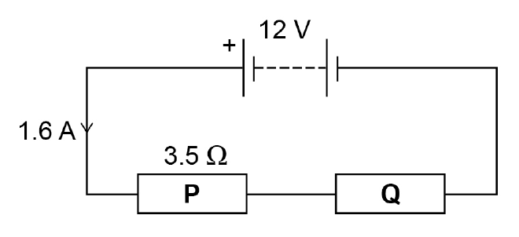

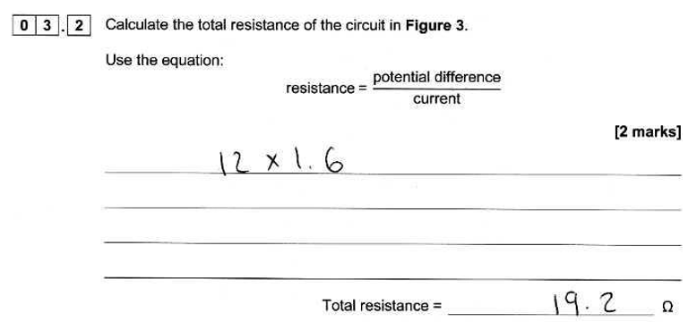

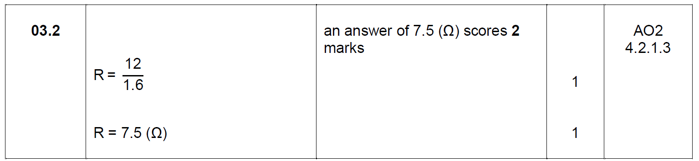

Standard demand, grades 4−5 (Foundation and Higher tier)

- Students will be given the prompt ‘Write down the equation that links…’ so they access AO1. These will be written in alphabetical order not necessarily in the way they need to be used.
- Calculation will involve something ‘extra’ e.g. simple transformation.

Example 11
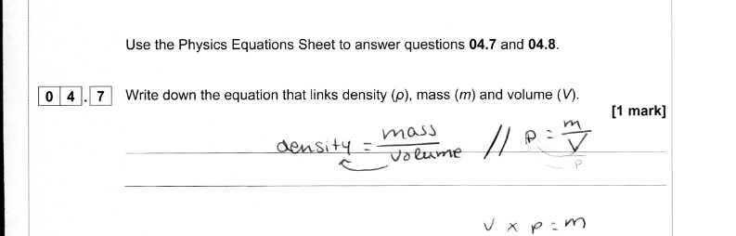
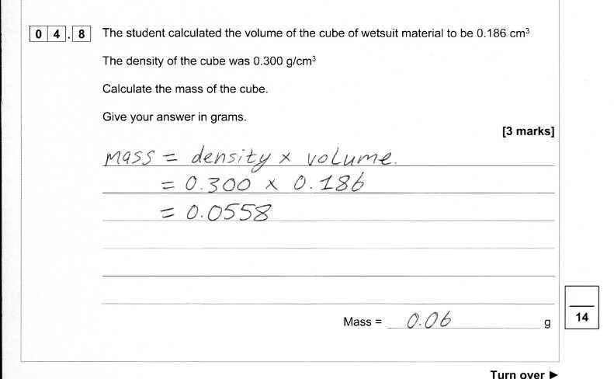

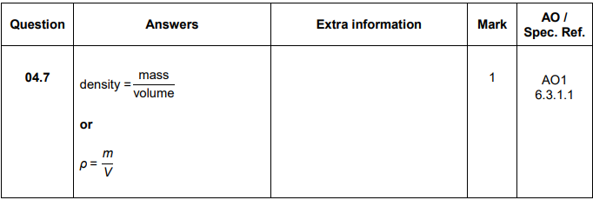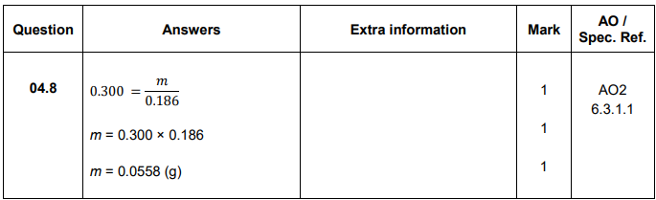

Example 12

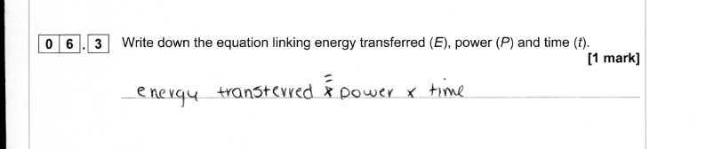
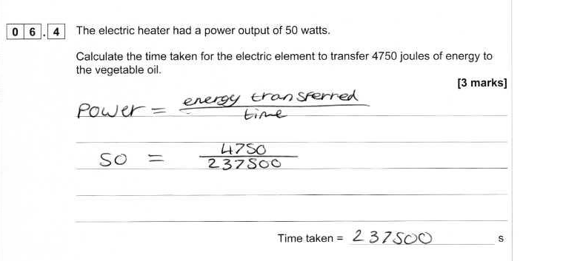
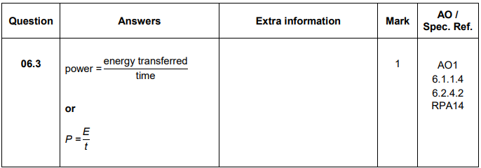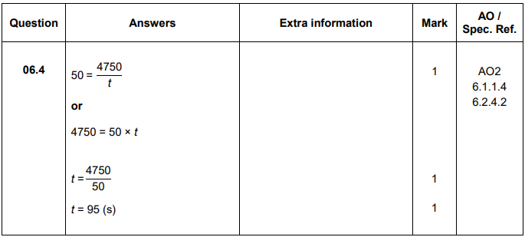

High demand, grades 6−9 (Higher tier only)
- No prompts about which equation to use.
- Students will not gain marks simply for writing the equation down without doing something with it (so no AO1).
- Questions will involve transformations or ‘something extra’.
- Could be multi-step

Example 13

For calculations that involve multiple steps (5 or 6 mark extended response on Higher tier) students may need to use more than one equation.

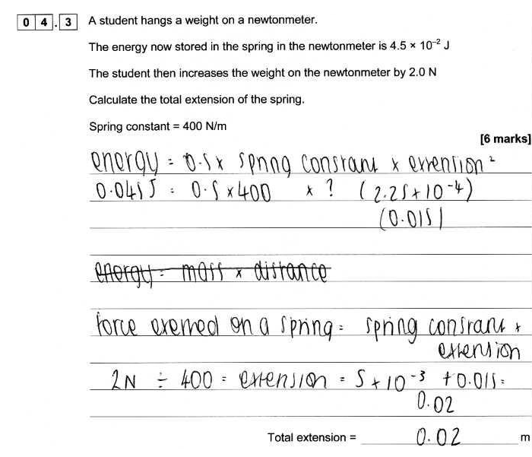
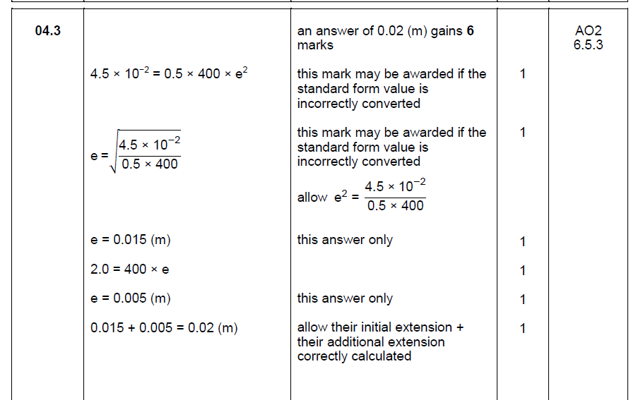

An example of a completely correct response, with all working shown, that scores 6 marks.

Graphs

We use a variety of graphs to test a range of skills covering all levels of demand. Students can use a pencil or a pen but a sharp pencil is best as they can then rub out mistakes.
Students may be asked to:
- plot the data from a table:
  - cross (x) or dots can be used but crosses (x) are easier to see.
  - marked for accuracy - different divisions of scales are used depending on demand.
- label the axis – use the headings in the data table to help decide on the labels.
- draw the scale – try and use most of the available graph paper so the examiner can see clearly what you have done.
- draw a line of best fit – in science because we are using real data, lines of best fit can be straight or curved. Look at the pattern in the data first to decide.

Simple bar charts: Example 14
AQA-8464P1F-QP-JUN18
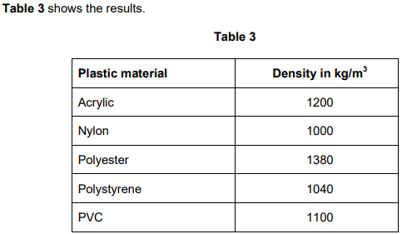

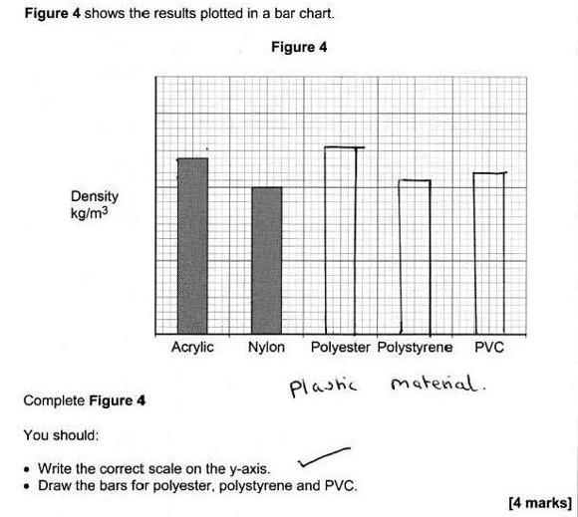
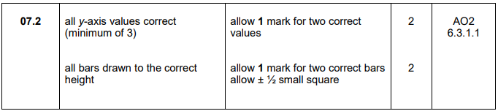

Line graph: Example 15
AQA-8464B1F-QP-JUN18

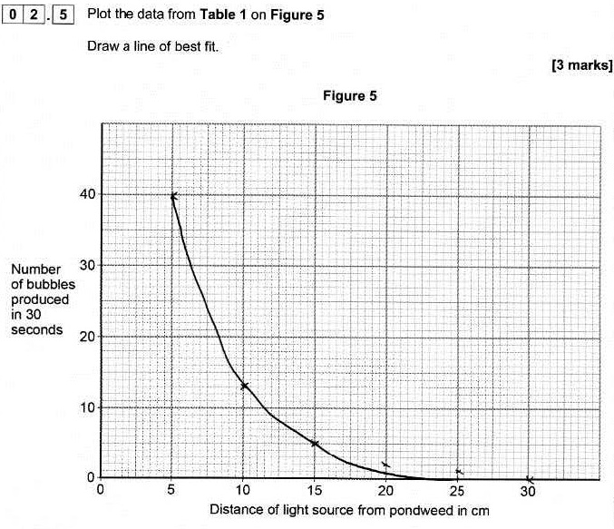

Line graph: Example 16
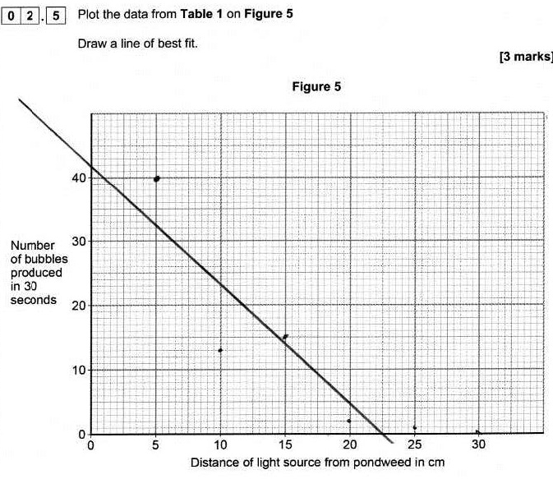

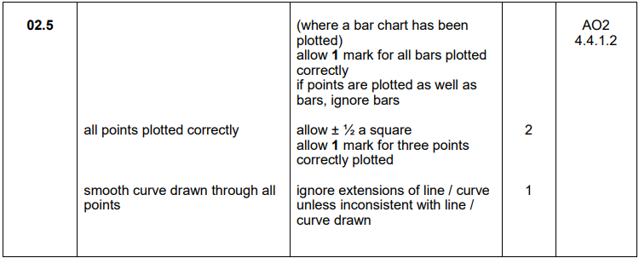

Line graph: Example 17

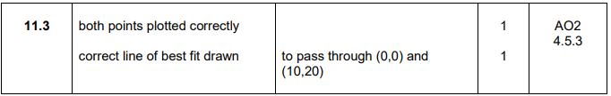

Extended response

One of the assessment criteria all exam boards have to assess is a student’s ability to write an answer that is ‘coherent, relevant, substantiated and logically structured’.

These questions carry 4 – 6 marks and are usually set at standard demand or above, so on the foundation tier they are often part of the last questions.
They are marked using ‘levels of response’ mark schemes (unless multi-step calculation).
Levels of response mark schemes provide a framework in which students are rewarded according to the level of skill they show and the correct content they include. There is not one right answer. The mark is determined by:
- looking at the overall quality of the answer
- taking into account the descriptor for each level
- taking into account the content included

Typical command works are plan, describe, explain, compare and evaluate. Each command word has a different levels descriptor.

When a student writes their answer they can:
- write in paragraphs
- use short sentences in bullet points
- use labelled diagrams, especially if it’s planning an experiment or writing the method. They need to refer to them in their answer, e.g. set up the equipment in the diagram and then …… .
A logically sequenced series of annotated diagrams can save time writing and may be clearer than a long written account.
- Use tables with headings for compare and evaluate questions. Students must make sure to explain what the table is showing. Statements, explanations and numerical data need to be clearly linked across the table so that like is being compared with like. An evaluation has to have a judgement at the end
Answers don’t need to be long; students need to be concise and keep to the point.
The number of answer lines is an indication of the maximum amount of space they should be using, not the space they must fill. Make sure students understand this and they shouldn’t be tempted to keep writing to fill the space. If they do they may end up contradicting themselves or including wrong statements that affect the overall quality of the answer.

Encourage students to always have a go at these questions as any relevant information may get them a mark and every mark counts!

Using bullet points and prose

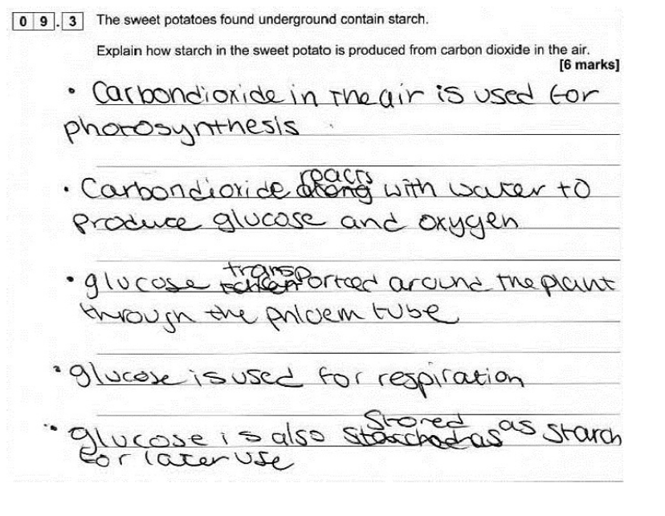
Commentary
This answer is given as a clear sequence of relevant bullet points, which link to give a clear account of what happens in the plant. The level of detail given is sufficient for Level 3 and this student gains full marks.

Using a table to layout similarities/differences and advantages/disadvantages

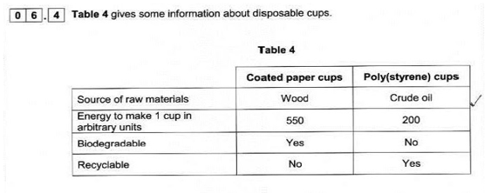
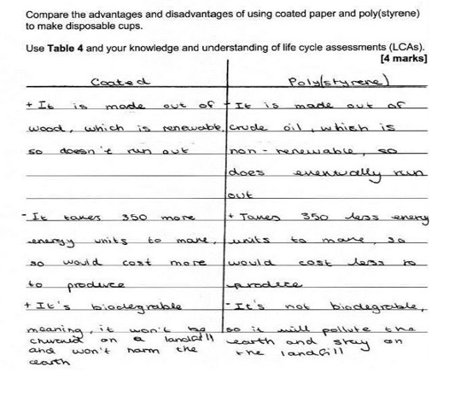
Commentary
This student has presented their comparison in tabular form, which is perfectly acceptable. They have identified scientifically relevant features of both types of cup, and clearly linked each feature to whether it is an advantage or disadvantage. The comparison of the features of the two types of cup is clearly shown in the tabular presentation, and there is numerical data to indicate the magnitude of the difference in cost production. This is a top Level 2 answer and deserves full marks.

Commentary 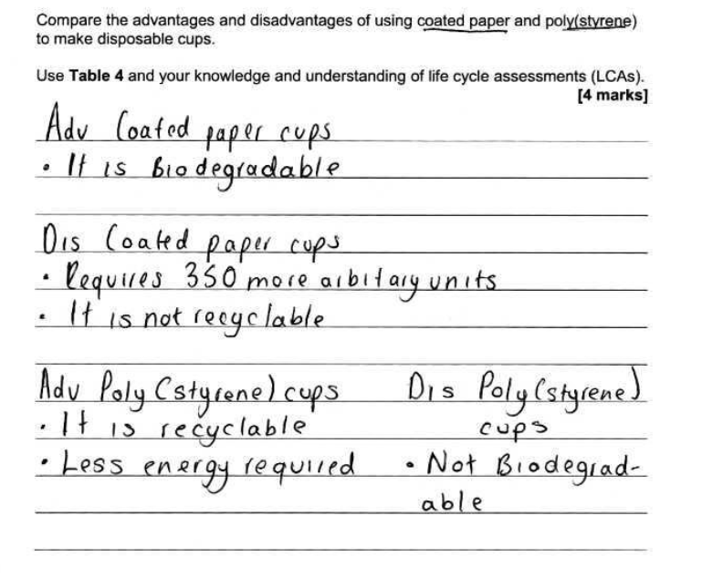
This answer to the same question is not as good and gets 1 mark. General advantages and disadvantages are identified here but there is no explanation of why its an advantage or disadvantage. They have just repeated the information in the table. What is needed is for example;
paper cups are not recyclable so they end up in landfill or they are biodegradable so they break down or rot. The layout doesn’t show how the two cups compare against each other

Using a labelled diagram

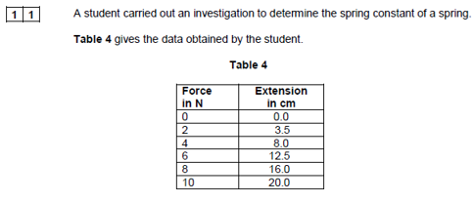
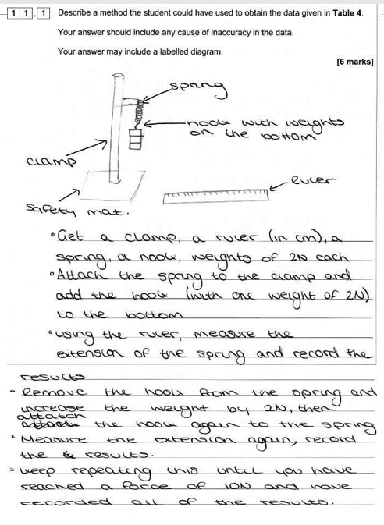
Commentary
The method given will produce a valid outcome, so is a level 3 response. There is a correct, labelled diagram, and if they had referred to this they didn’t need to rewrite the set up as in bullet 1 and 2. The response lacks some detail as there is no reference to calculating extension or causes of inaccuracy, so this scores 5 marks.

Command words

Command words are the words and phrases used in exams that tell students how they should answer a question.

Calculate Students should use numbers given in the question to work out the answer.
Choose Select from a range of alternatives.
Compare This requires the student to describe the similarities and/or differences between things, not just write about one.
Complete Answers should be written in the space provided, for example on a diagram, in spaces in a sentence, or in a table.
Define Specify the meaning of something.
Describe Students may be asked to recall some facts, events or process in an accurate way.
Design Set out how something will be done.

Determine Use given data or information to obtain and answer.

Draw To produce, or add to, a diagram.

Estimate Assign an approximate value.

Evaluate Students should use the information supplied, as well as their knowledge and understanding, to consider evidence for and against.

Explain Students should make something clear, or state the reasons for something happening.

Give Only a short answer is required, not an explanation or a description.

Identify Name or otherwise characterise.

Justify Use evidence from the information supplied to support an answer.

Label Provide appropriate names on a diagram.

Measure Find an item of data for a given quantity.

Name Only a short answer is required, not an explanation or a description. Often it can be answered with a single word, phrase or sentence.

Plan Write a method.

Plot Mark on a graph using data given.

Predict Give a plausible outcome.

Show Provide structured evidence to reach a conclusion.

Sketch Draw approximately.

Suggest This term is used in questions where students need to apply their knowledge and understanding to a new situation.
Use The answer must be based on the information given in the question. Unless the information given in the question is used, no marks can be given. In some cases students might be asked to use their own knowledge and understanding.

Write Only a short answer is required, not an explanation or a description

Working scientifically

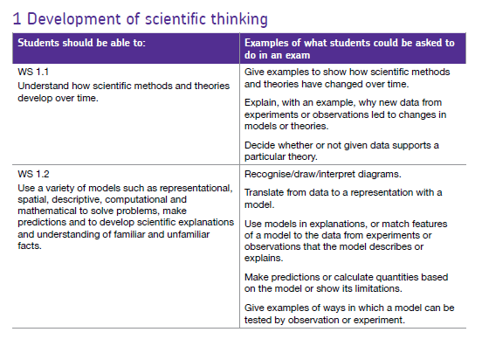
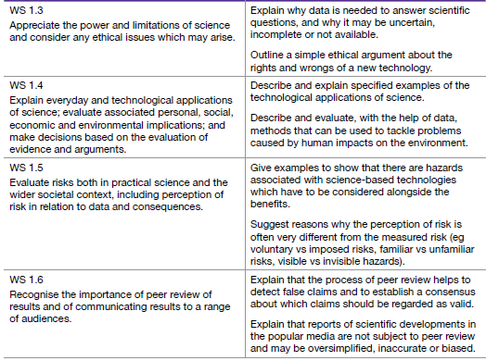

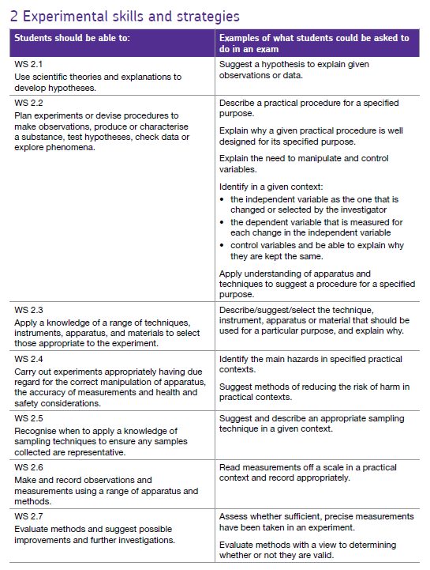

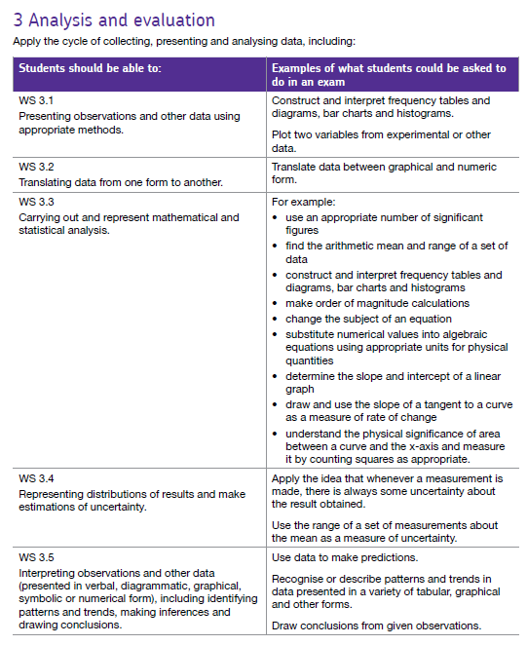
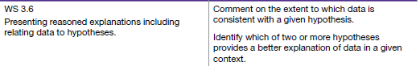

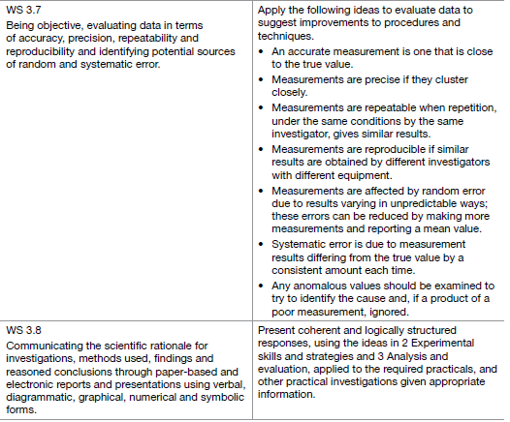
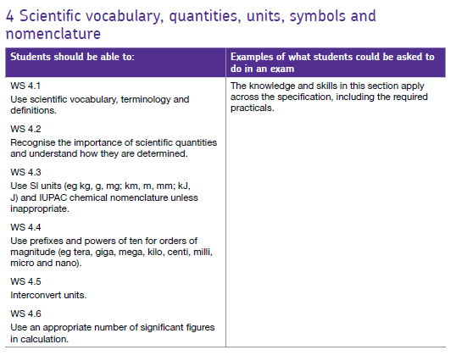

Elements covered in practical questions

Look at this common biology question. Can you identify any of the skills from the list above that are being assessed?

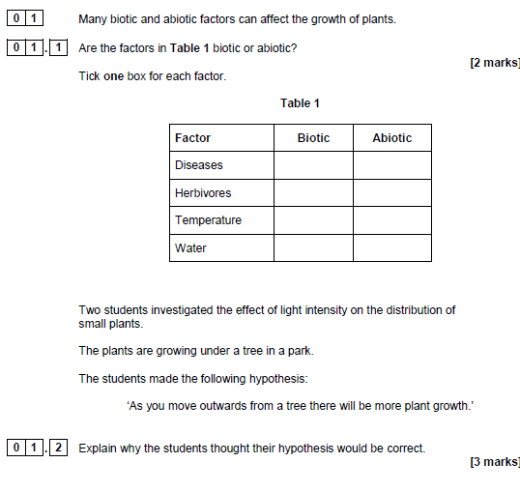
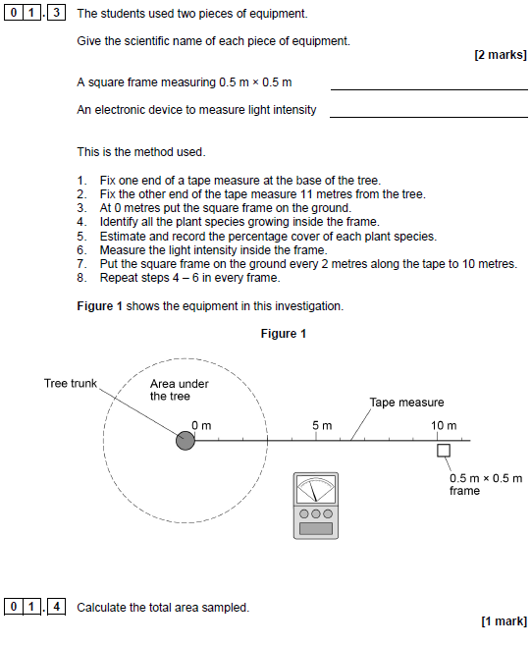
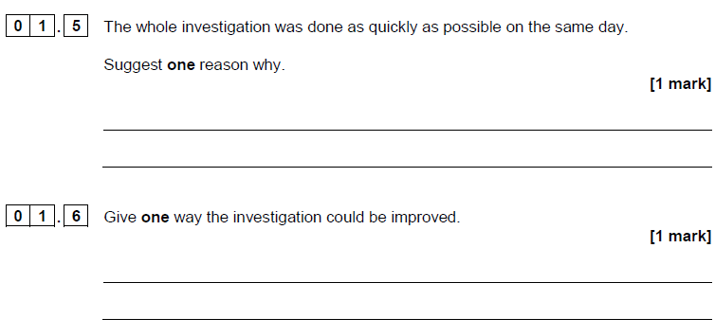
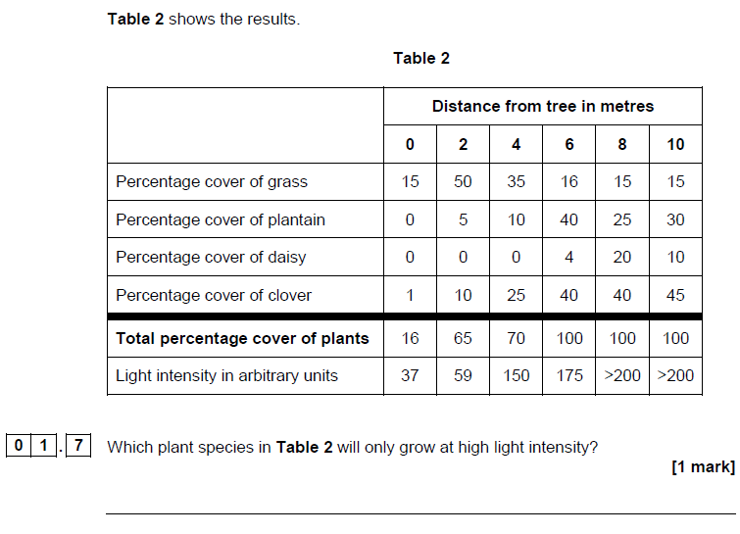
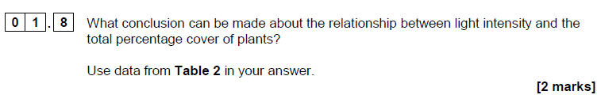
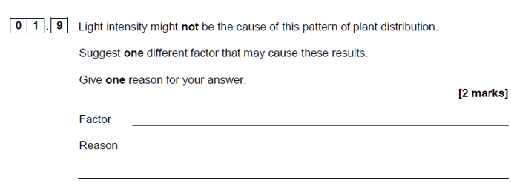

Contact us
Our friendly team will be happy to support you between 8am and 5pm, Monday to Friday.

Tel: 01483 477 756
Email: gcsescience@aqa.org.uk
Twitter: @AQA

aqa.org.uk

