ASE 2023
Developing A-level assessment skills through practical

Resource booklet

Spring 2023

Contents | Page
Practical skills to be assessed in written papers | 4
CPAC | 5
Apparatus and techniques | 7
Assessment objectives | 9
2022 A-level Science practical questions | 10

Practical skills to be assessed in written papers

Overall, at least 15% of the marks for all A-level Biology, Chemistry and Physics courses will require the assessment of practical skills. In order to be able to answer these questions, students need to have been taught, and to have acquired competence in, the appropriate areas of practical skills as indicated in the tables of coverage below.

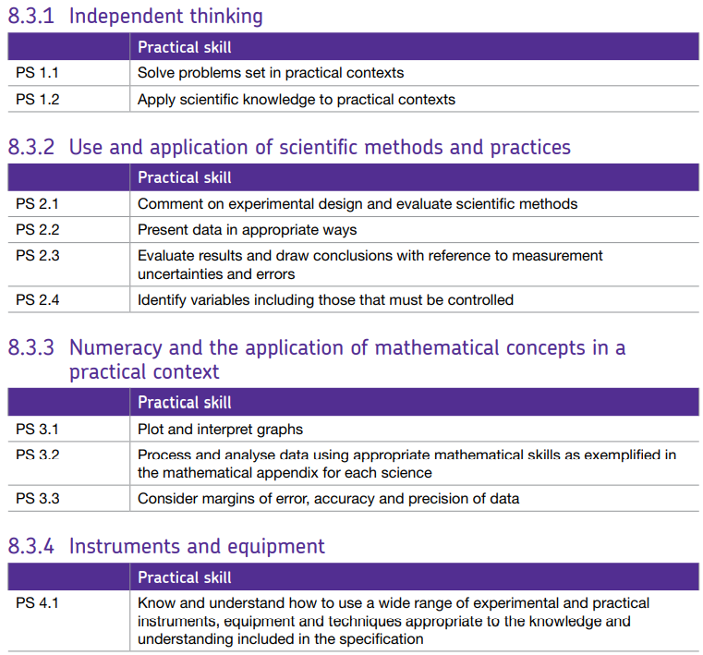

CPAC

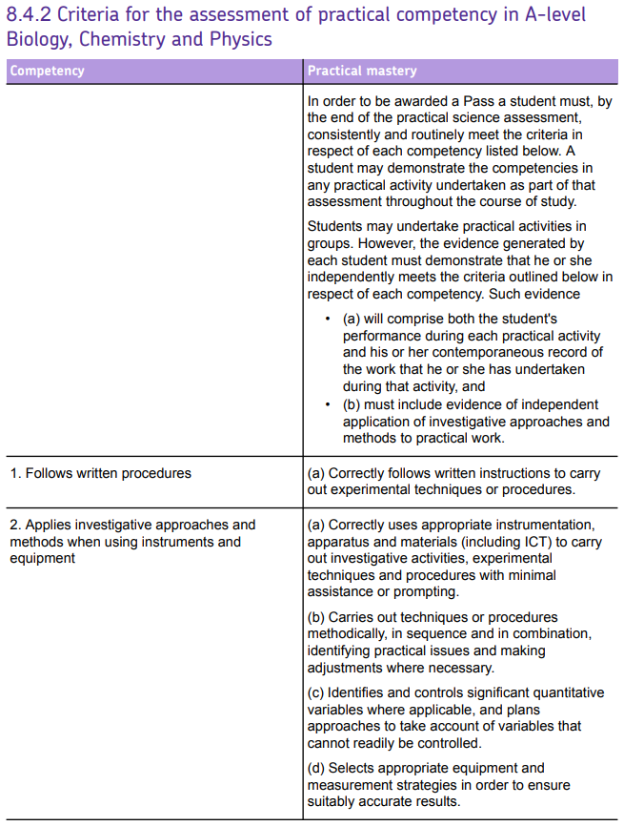

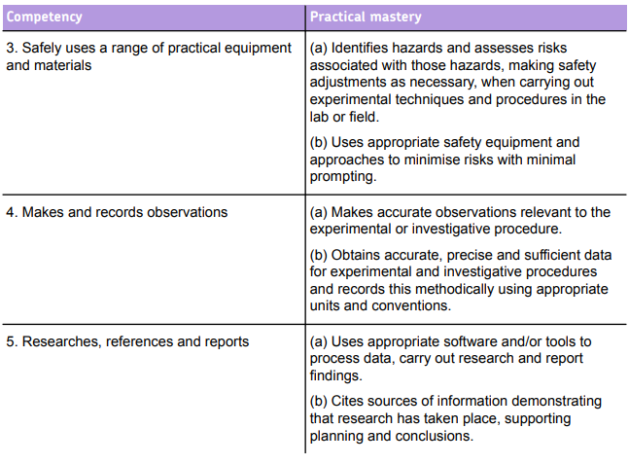
Apparatus and techniques

Biology ATs
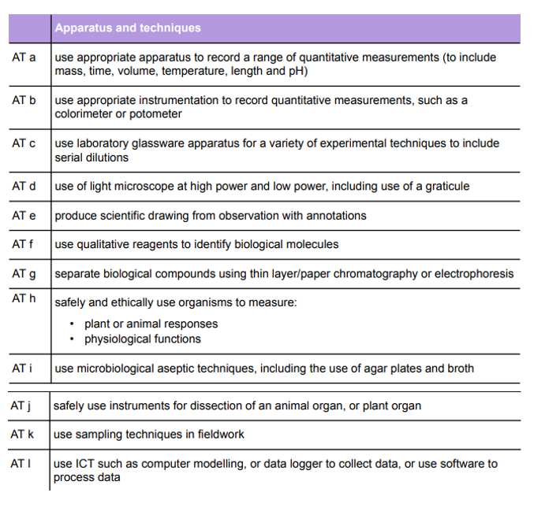

Chemistry ATs

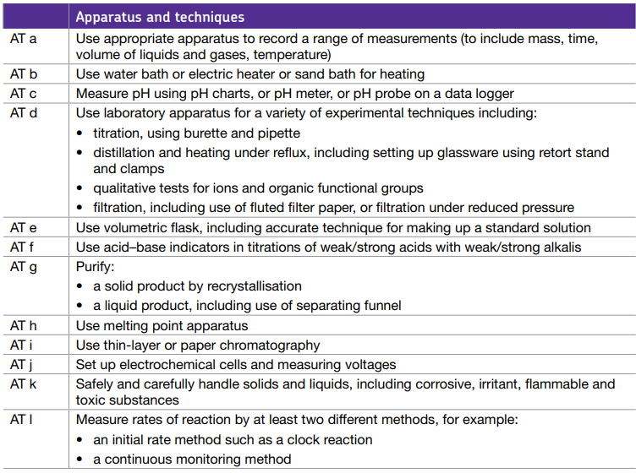

Physics ATs

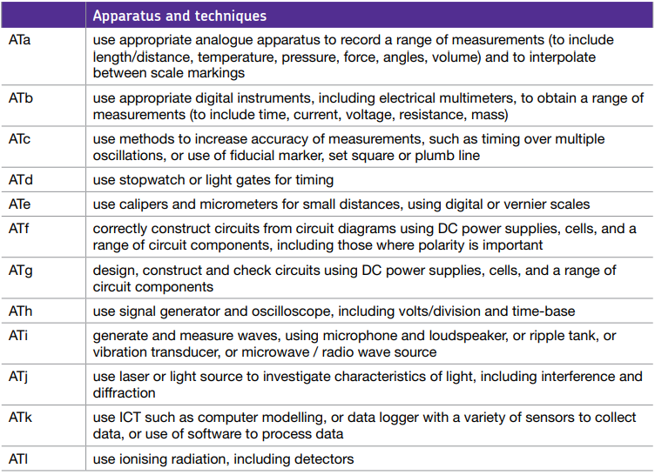

Assessment objectives

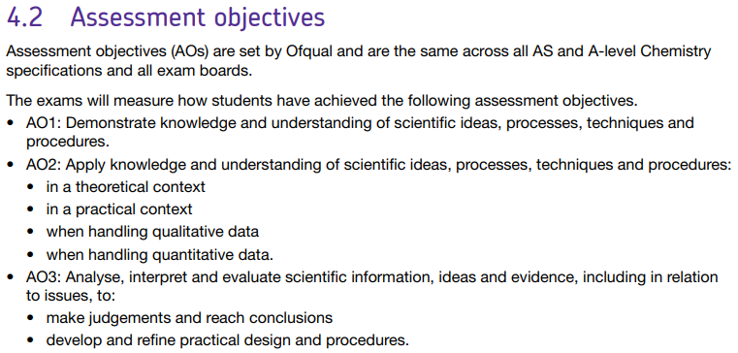
2022 A-level Science practical questions

Questions about methods or techniques

Biology P1 Q6.3

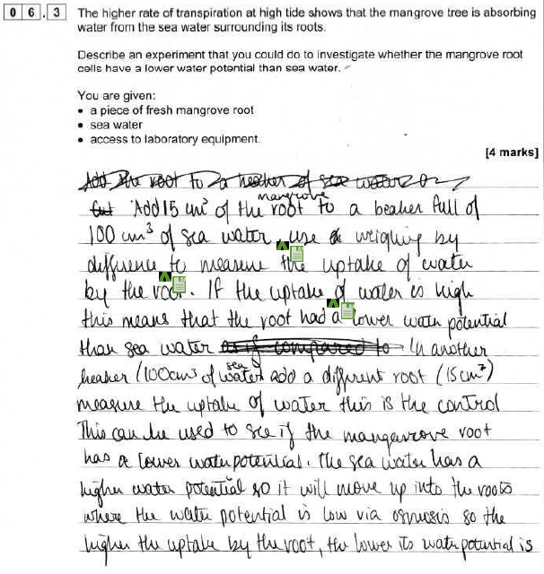

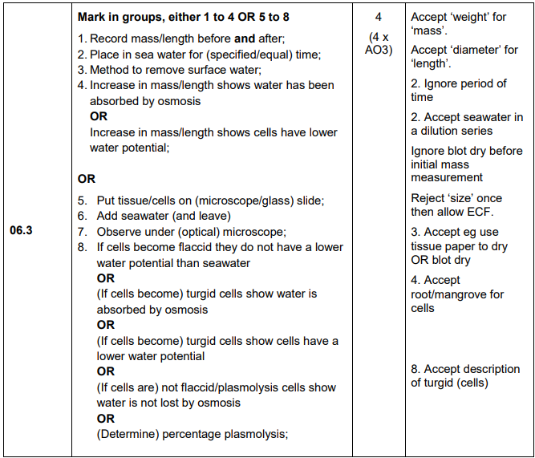

Commentary

Needs reference to time for MP2. Accept set time, but not period of time (as this could vary). Must say, weight before and after (or similar wording). Uptake is not enough - must refer to mass or length change and lower WP for MP4.

Chemistry P1 Q4.4

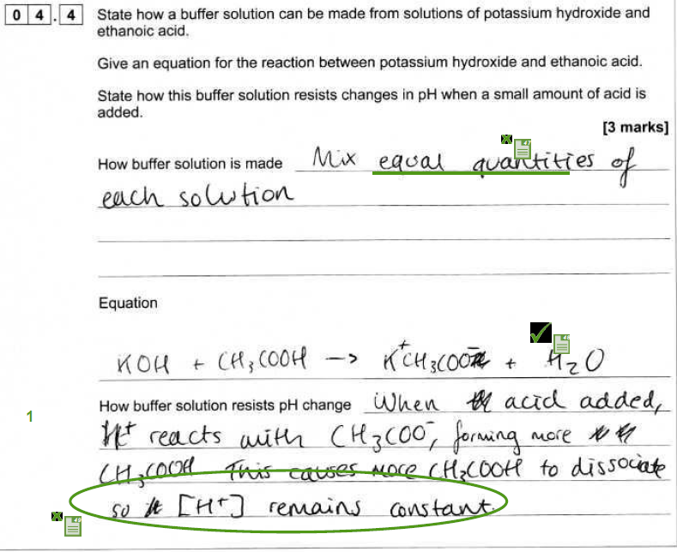
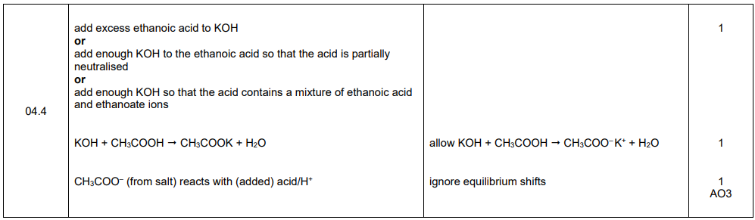

Commentary

No MP1, MP2 awarded, MP3 contradiction.

Physics P3 Q2.2
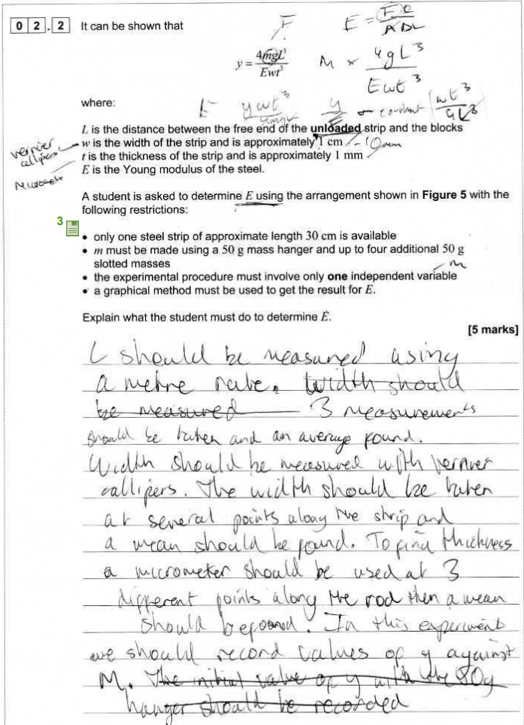

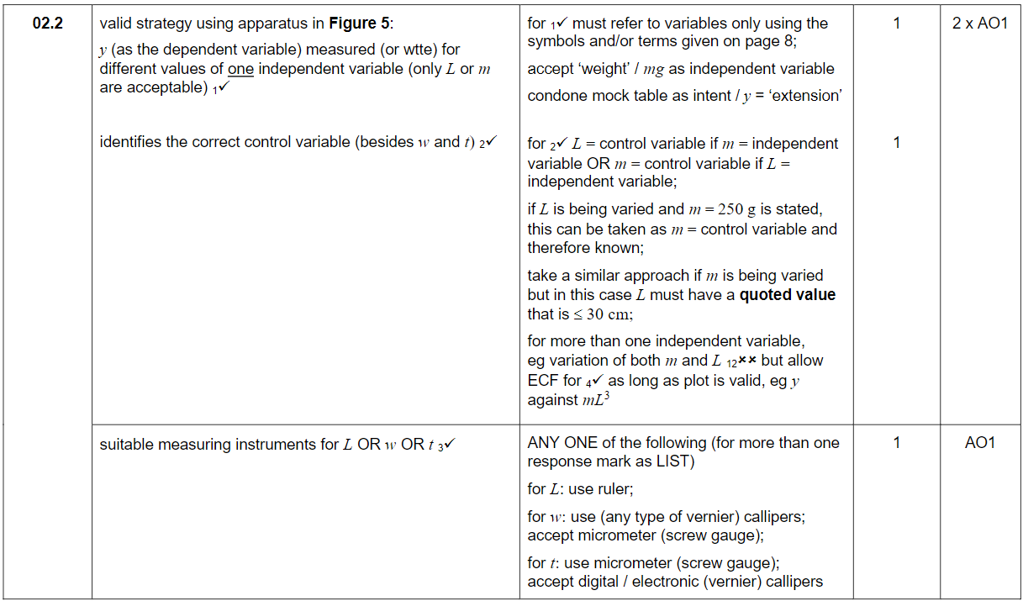
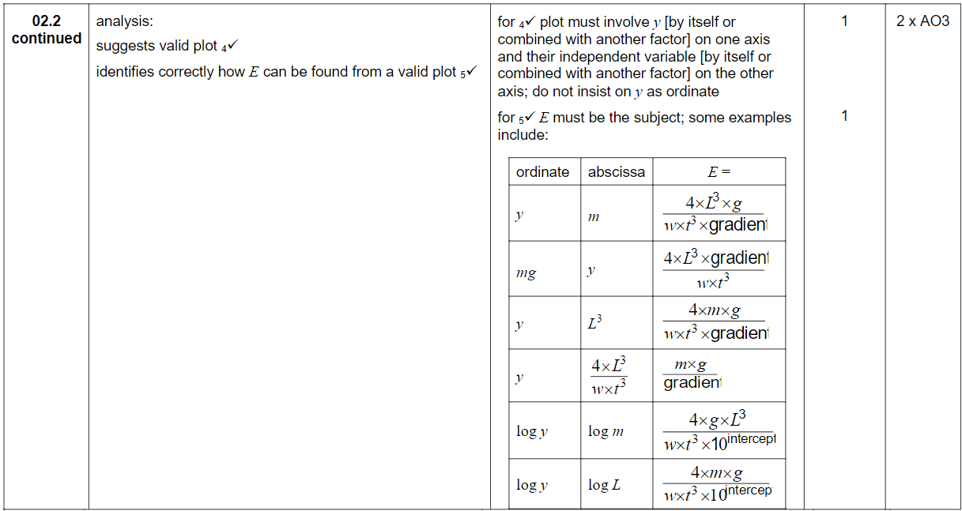

Commentary

MP1 awarded. An explicit statement that L (by itself and not in combination with other properties) is constant, must be seen for MP2. Plenty of MP3 evidence. Although m was varied multiplying by g to get F is acceptable for MP4. 1/gradient not gradient in expression for E loses MP5.

Understanding the science

Chemistry P3 Q4.1

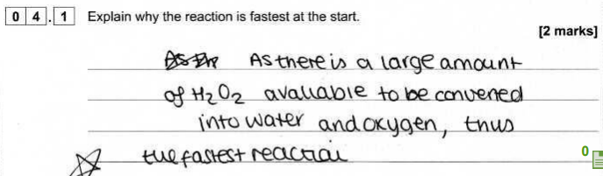

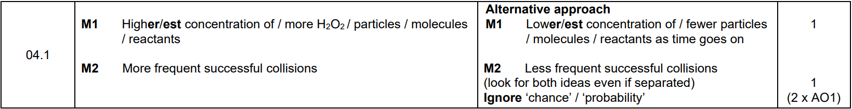

Commentary

MP1 large amount not enough, not relative amount.

Physics P3 Q4.5

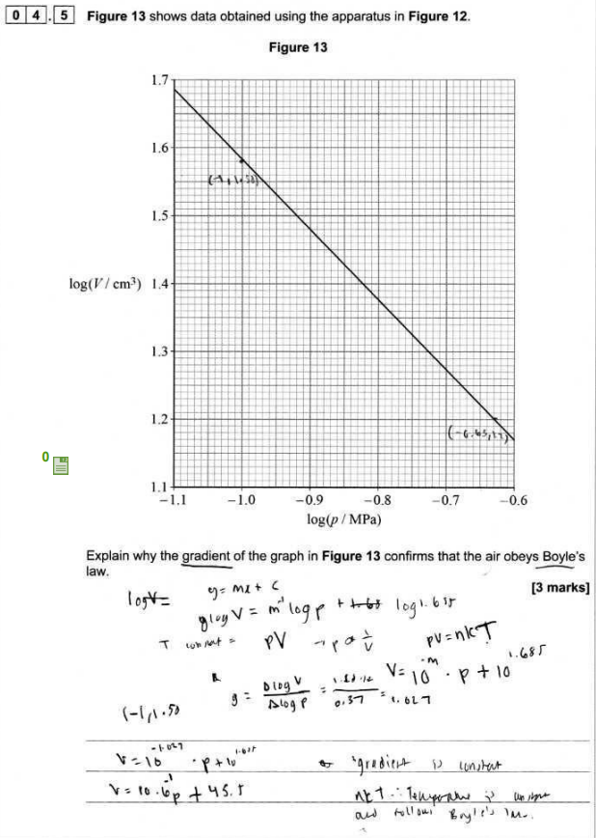

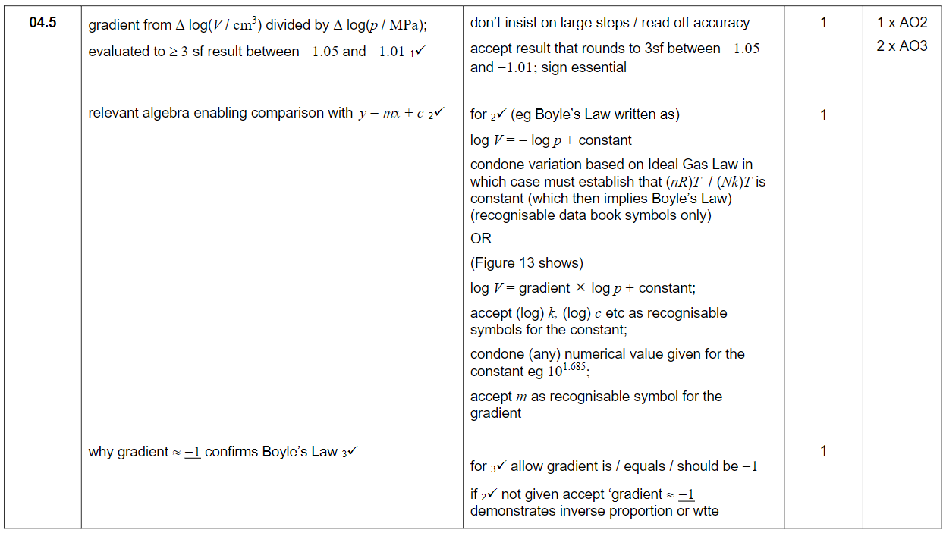

Commentary

Gradient calculation is fine but no minus sign with result so loses MP1. Can condone constant = log 1.685 but don’t allow log V = m^-1 x log p + log 1.685 so loses MP2. Need more than ‘gradient is constant’ for MP3.

Biology P3 Q3.5 (Suggest)

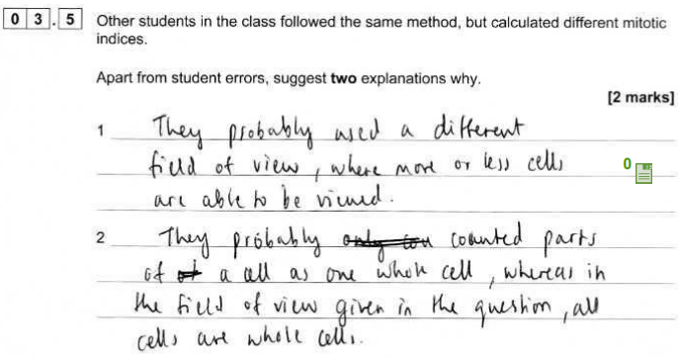

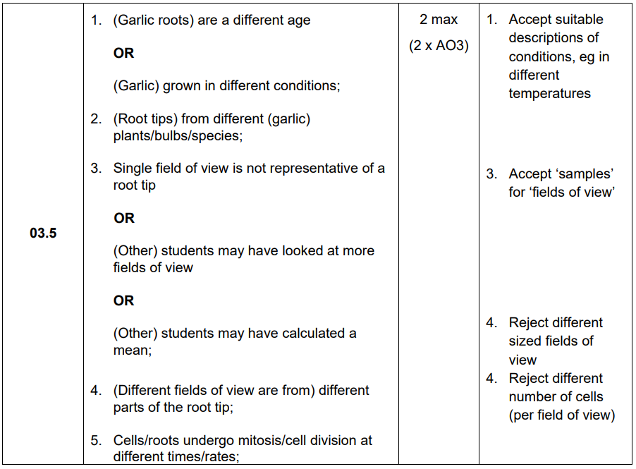

Commentary

‘Different fields of view’ is rejected.

Physics P3 Q1.3

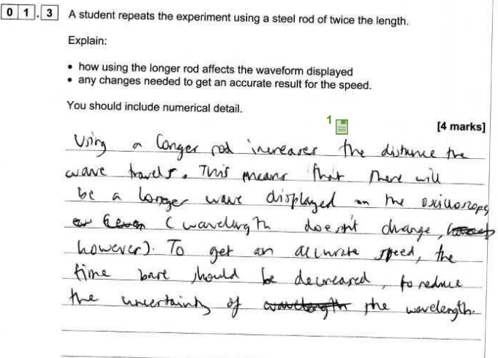

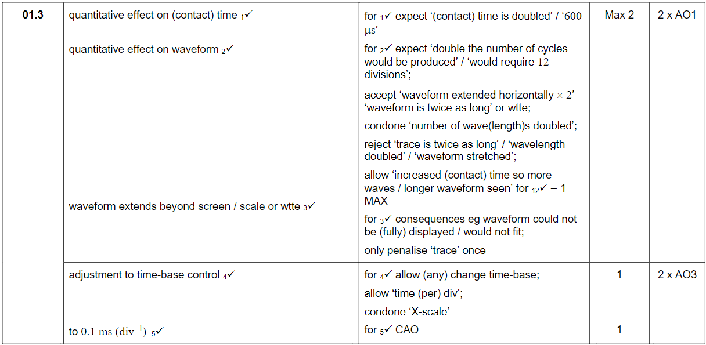

Commentary

Although ‘wave’ is ok for ‘waveform’ ‘longer wave’ is not quantitative so deny MP2.
Decrease/change time-base for MP4.

Chemistry P3 Q3.7

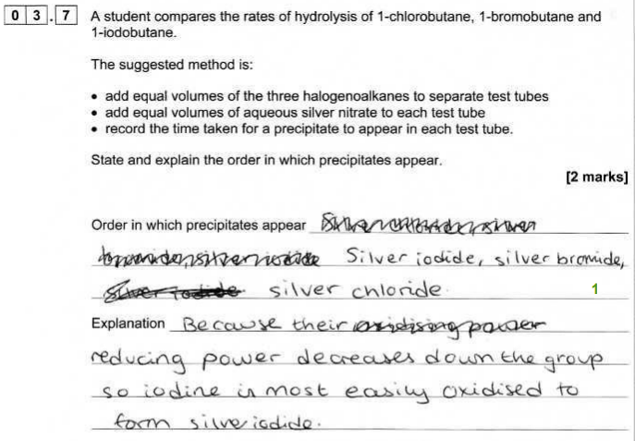

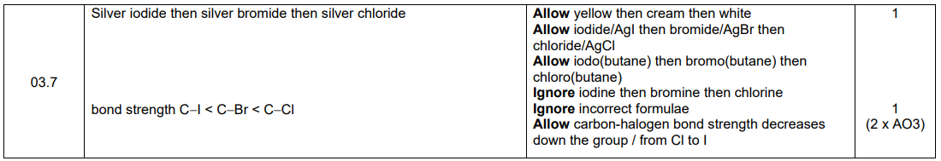

Biology P2 Q4.2

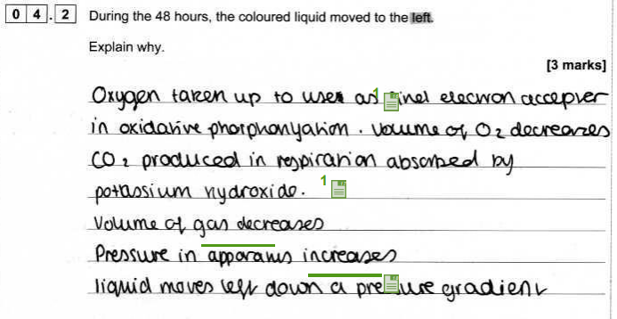

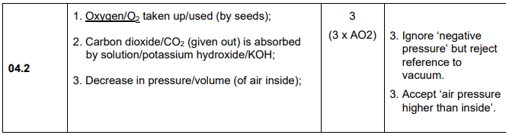

Commentary

‘Pressure in apparatus increases’ disqualifies MP3.

Calculate/deduce questions

Biology P2 Q4.5

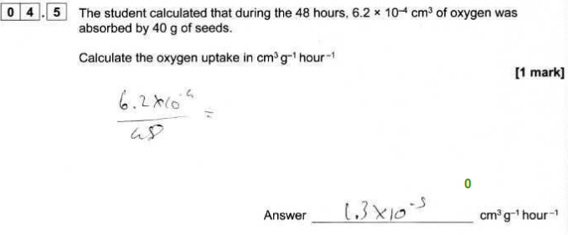

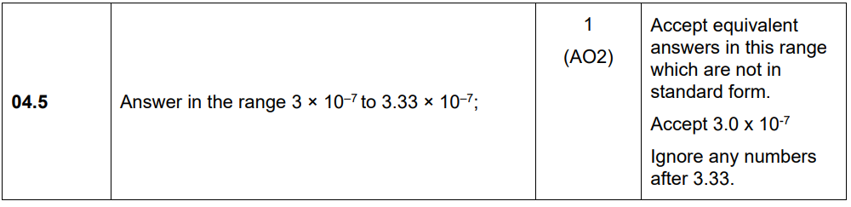

Physics P3 Q1.2

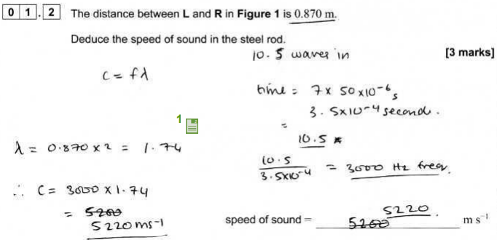

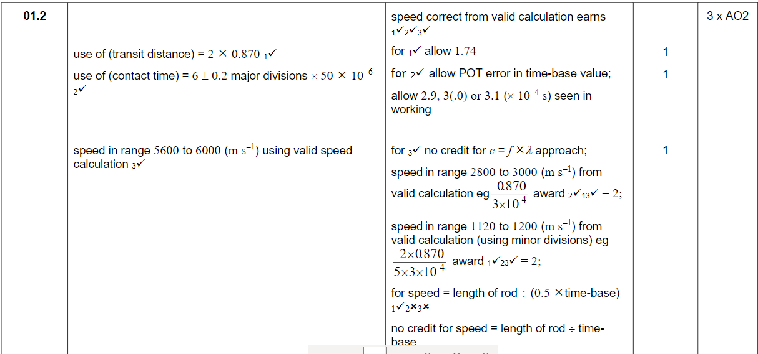

Chemistry P2 Q9.2
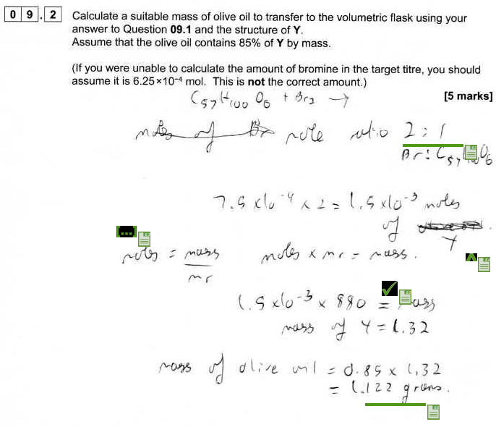
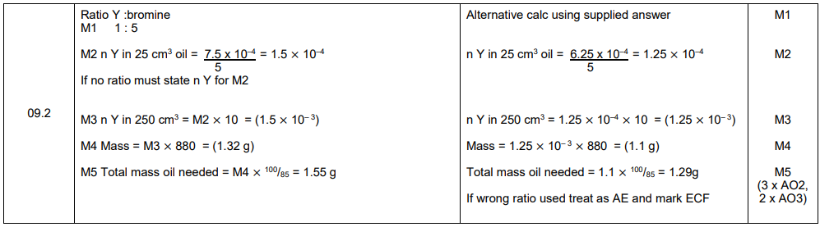

Commentary

To get MP2 they should have divided by 2.

Contact us
Tel: 01483 477756
Email: alevelscience@aqa.org.uk
Twitter: @AQA

aqa.org.uk

