GCSE and A-level
SCIENCE
Progression in maths in science through the key stages

Resource booklet

Published: Spring 2022

Contents

Contents | Page
Links to online resources | 4
Example questions used in the presentation | 5
Starter activity flowchart | 12
Example lesson activities relating to use of standard form | 13
Progression of demand in other maths skills in science | 15

Links to online resources

Below are links to the resources cited in the presentation:

- Focus on success: Maths in science
- GCSE Maths skills teaching guides
- Lesson activity: GCSE to A-level progression:
  - Biology
  - Chemistry
  - Physics
  - Environmental Science
- Maths skills briefings for A-level sciences
- Exampro
- ASE: The Language of Mathematics in Science

Example questions used in the presentation

Use of standard form is not specifically mentioned at Key Stage 3 science.

The programme of study for Key Stage 3 maths states that:
Pupils should be taught to interpret and compare numbers in standard form A × 10^{n} 1 ≤ A < 10, where n is a positive or negative integer or zero

From the GCSE Maths criteria (basic Foundation criteria: no extra criteria for Higher tier):
N9 calculate with and interpret standard form A × 10^{n} 1 ≤ A < 10, where n is an integer (with and without a calculator)

From the GCSE science maths criteria:
1b Recognise and use expressions in standard form

From the A-level science maths criteria:
AO2 Recognise and use expressions in standard form

National curriculum in England: mathematics programme of study - Key Stage 3 Used under the Open Government Licence v3.0.

Remember that:

- GCSE Foundation tier level of maths must ‘not be lower than that which is expected of learners at Key Stage 3, as outlined in the Department for Education’s document Mathematics programmes of study: Key stage 3.’
- GCSE Higher tier level of maths must ‘not be lower than that of questions and tasks in assessments for the foundation tier in a GCSE Qualification in Mathematics.’
- On GCE (AS and A-level) papers, mathematical skills must be ‘at level 2 or above’ (ie equivalent to Higher tier GCSE mathematics or above).

GCSE Subject Level Conditions and Requirements for Combined Science (2021) and GCE Subject Level Conditions and Requirements for Science. Used under the Open Government Licence v3.0.

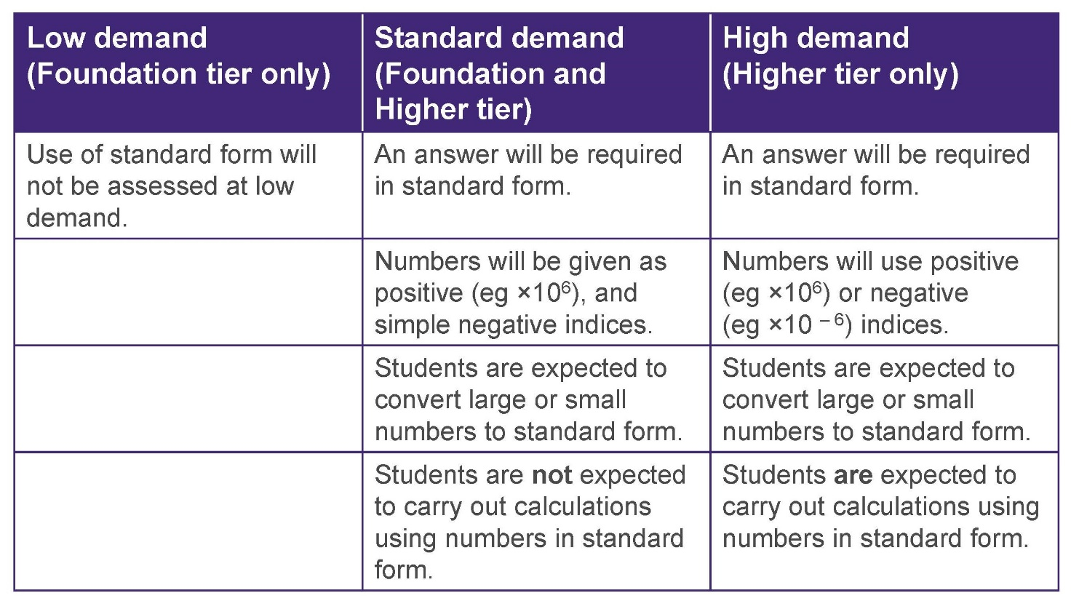

Example 1

Example taken from Key Stage 3 maths Exampro question bank

In this question, students need to convert a very large number into standard form (9.43 × 10¹² km).

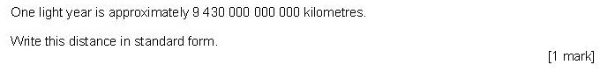

Example 2

Q7.5, GCSE Biology 2F, June 2019

In this Standard demand question, students need to calculate the volume of a pond, then multiply the volume by the number they had calculated in the previous question. The resulting large number needs to be converted to standard form, which is equivalent to the demand of Key Stage 3 and what we ask at Standard demand GCSE.

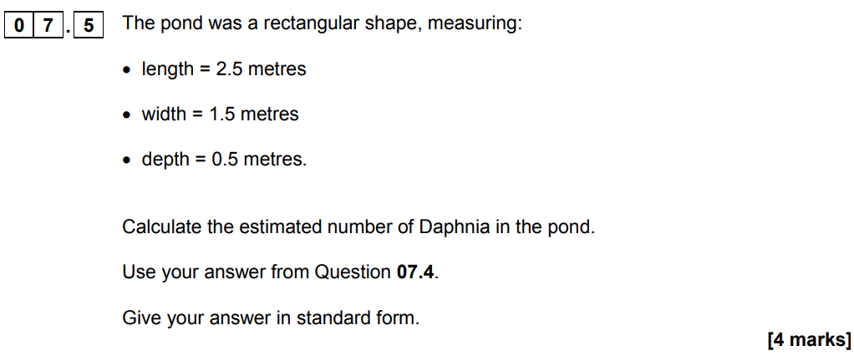

Mark scheme

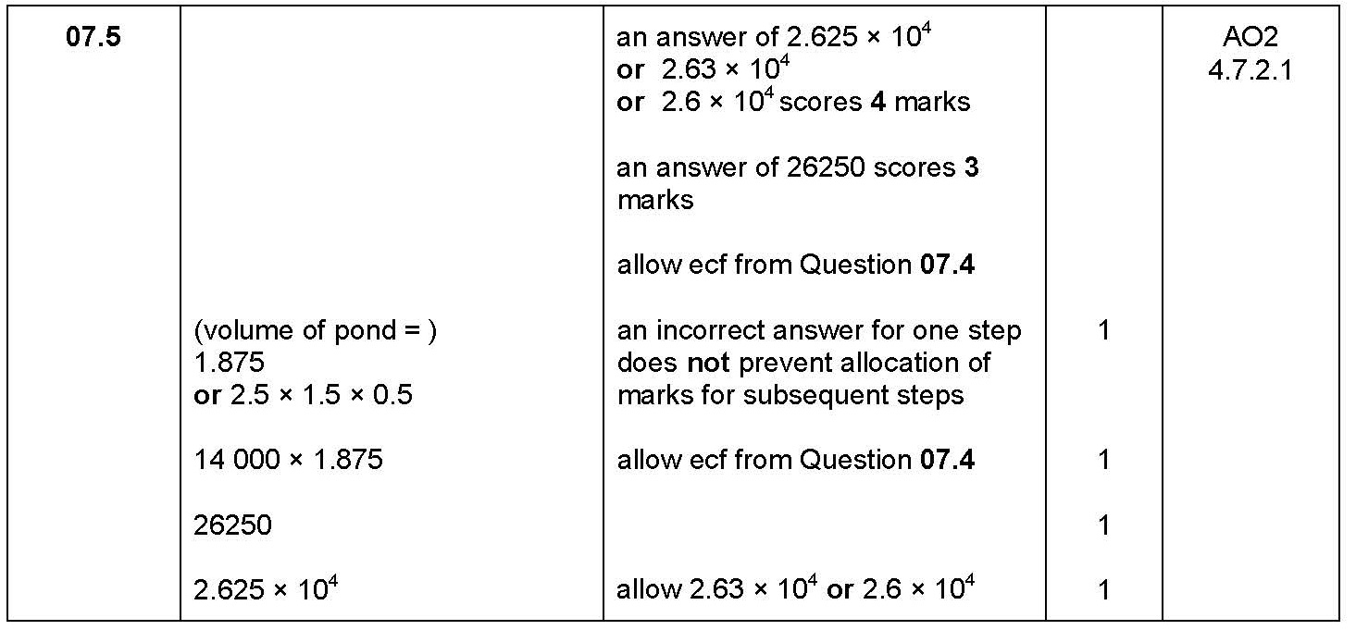

Example 3

Q7.4, GCSE Science: Synergy 3H, June 2019

In this High demand question, students need to multiply a number in standard form by 1000 and quote the resulting number correctly in standard form. Negative indices are involved. This is a step up from the Key Stage 3 criteria and matches GCSE Maths.

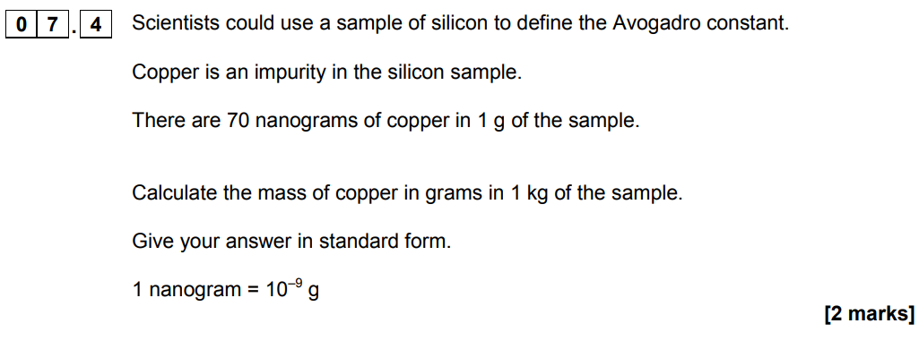

Mark scheme

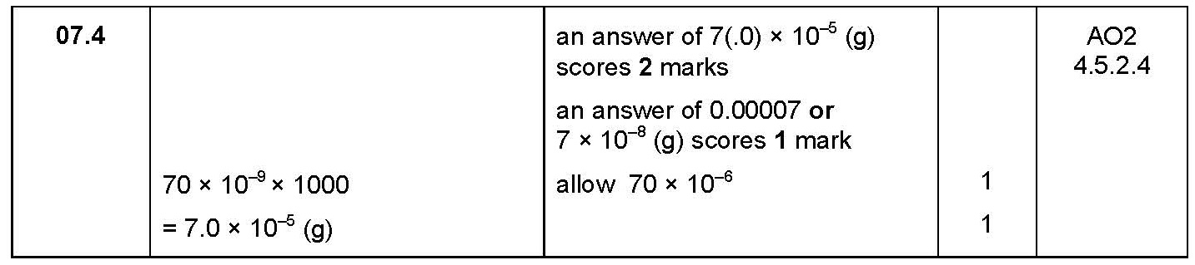
Example 4

Q2.1, AS Chemistry Paper 1, June 2018

The first parts of this calculation involve students multiplying a number in standard form (negative indices) by 42, to give an answer in 1 g of material, then multiplying that answer by 1000 to gain the amount in 1 kg of material. Compare the demand with that of Example 3.

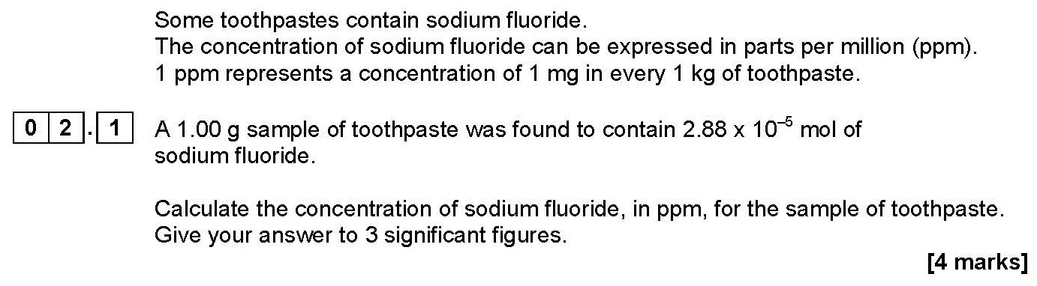

Mark scheme

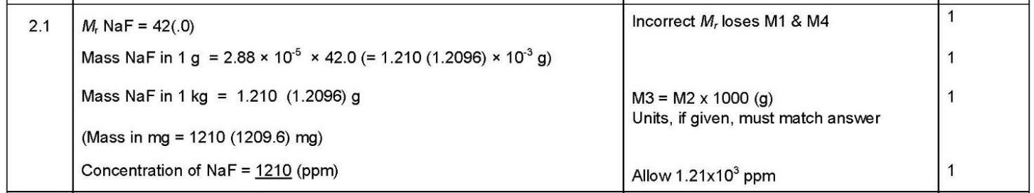

Example 5

Q9.2, GCSE Chemistry 2H, June 2018

In this High demand question, students need to recognise the 2:1 ratio and divide the number in standard form by 2 to choose the correct option. This is a step up from Key Stage 3, in that students are doing more than simply interpreting numbers in standard form.

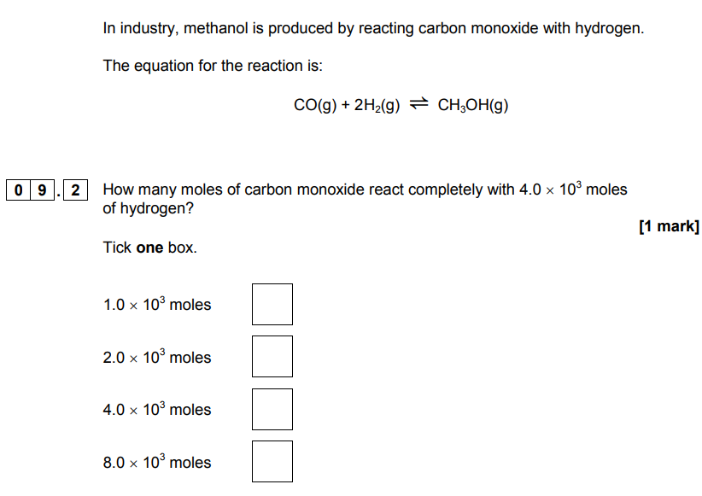

Mark Scheme

Example 6

Q2.2, AS Chemistry Paper 1, June 2018

In this question, students need to multiply the number in standard form by 75 then by 1000 to determine an answer in milligrams. Negative indices are involved. Compare the demand with that of Example 5.

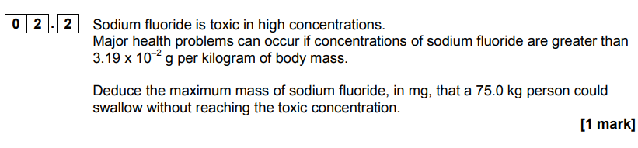

Mark scheme

Starter activity flowchart

Using starter activities to ascertain student confidence with using standard form – a simple flowchart

Using the maths skill in a context
Can the student convert a large number to standard form /from standard form to ordinary in a simple science context?

(eg Example 2)
No
No
Yes
Yes
Using the maths skill in a higher demand context
Can the student carry out a calculation using standard form?

(eg Example 3)

Start with the maths skill
Can the student convert a large number to standard form/from standard form to ordinary form?

(eg Example 1)
Student needs more help mastering this skill.

Example lesson activities relating to use of standard form

Chemistry

The amount of a substance is measured in moles (the SI unit). The mass of one mole of a substance in grams is numerically equal to the relative formula mass of the substance.
One mole of a substance contains the same number of the stated particles, atoms or ions as one mole of any other substance. The number of atoms, molecules or ions in a mole of a given substance is the Avogadro constant. The value of the Avogadro constant is

6.02 × 10²³ per mole.

Complete the table. Use the periodic table on page 21 to help you.

Substance | Mass of substance in grams | Amount in moles | Number of particles
Helium |  |  | 18.12 × 10²³
Chlorine (Cl) | 14.2
Methane |  | 4
Sulfuric acid | 4.905

Activity 14 Moles

Physics

Activity 11 Standard form
1. Write the following numbers in standard form.
a. 379 4
b. 0.0712

- Use the data sheet to write the following as ordinary numbers.

  - The speed of light
  - The charge on an electron

- Write one quarter of a million in standard form.

Environmental science

Activity 12 Maths skills
1. In 2017, the city of Manchester began a ‘City of Trees’ project. The project plans to plant 3 million trees over the next 25 years.

It was suggested that the council plant 3.6 × 10⁵ trees in the first year. The rest of the trees would be planted in equal numbers over the remaining years.
Calculate how many trees would need to be planted in each of the remaining years. Give your answer in standard form.

Progression of demand in other maths skills in science

The examples given demonstrate the progression in demand of the specified skill from Key Stage 3 science through to Key Stage 4 and into Key Stage 5.

You might like to discuss further with colleagues in Science and in Maths to devise common approaches to teaching and learning of these skills to enable all students to progress smoothly through their science courses.

The programme of study for Key Stage 3 science is not specific in what maths skills must be taught:

Pupils should be taught to apply mathematical concepts and calculate results.

Use of significant figures

From the programme of study for Key Stage 3 maths
Pupils should be taught to round numbers and measures to an appropriate degree of accuracy [for example, to a number of decimal places or significant figures].

From GCSE maths criteria (Foundation: no extra criteria for Higher tier)
N15 (basic Foundation content) round numbers and measures to an appropriate degree of accuracy (eg to a specified number of decimal places or significant figures); (additional Foundation content) use inequality notation to specify simple error intervals due to truncation or rounding

From the GCSE science maths criteria
2a Use an appropriate number of significant figures

From the A-level science maths criteria
A1.1 Use an appropriate number of significant figures

Remember that:
- On GCSE Foundation tier papers the level of maths must be: ‘not lower than that which is expected of Learners at Key Stage 3, as outlined in the Department for Education’s document Mathematics programmes of study: key stage 3’
- On GCSE Higher tier papers the level of maths must be: ‘not lower than that of questions and tasks in assessments for the foundation tier in a GCSE Qualification in Mathematics’
- On GCE (AS and A-level) papers mathematical skills must be ‘at level 2 or above’ (ie equivalent to Higher tier GCSE mathematics or above).

National curriculum in England: mathematics programme of study - Key Stage 3 Used under the Open Government Licence v3.0 GCSE Subject Level Conditions and Requirements for Combined Science (2021) and GCE Subject Level Conditions and Requirements for Science. Used under the Open Government Licence v3.0.

Example Key Stage 3 questions in a science context

Examples taken from Exampro Key Stage 3 maths and Beta maths for science question banks.

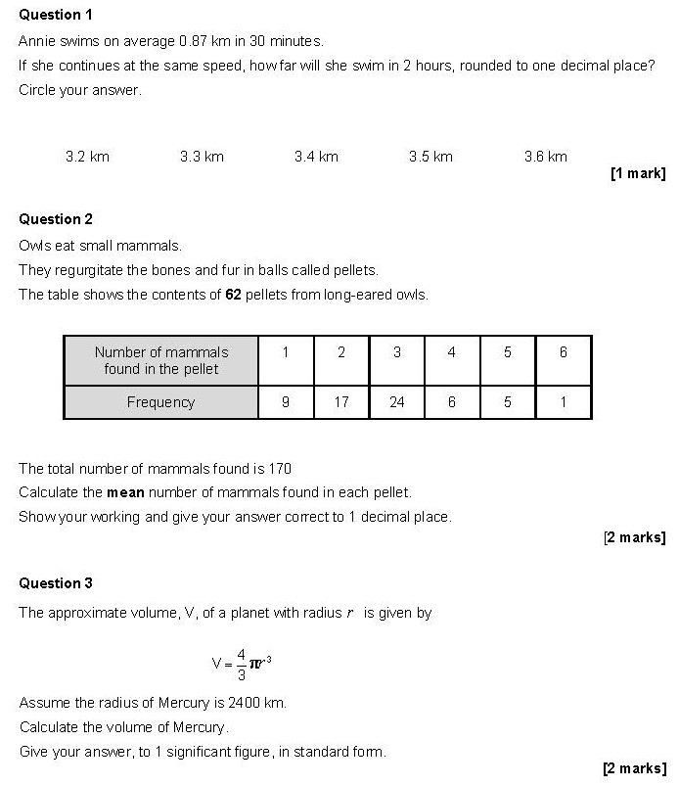

Examples from GCSE sciences

Progression of demand in GCSE assessments.

Low demand  (Foundation tier only) | Standard demand  (Foundation and Higher tier) | High demand  (Higher tier only)
Significant figures not assessed at low demand, but students may be asked to give correct number of decimal places | Students will be expected to round down correctly | Students will be expected to round down correctly
 |  | Students will also be expected to round up correctly

In questions where there is a mark for significant figures (or decimal places) the prompt ‘give your answer to x significant figures’ (or ‘give your answer to x decimal places’) will be given.

Calculation questions are often set at a mixture of levels of demand.

Example 7

Q7.5, GCSE Chemistry 1F, SAMs 1

This question is a mixture of Standard and Low demand – three marks for the overall calculation are set at Standard demand, but the requirement for giving the answers to 2 decimal places is set at Low demand.

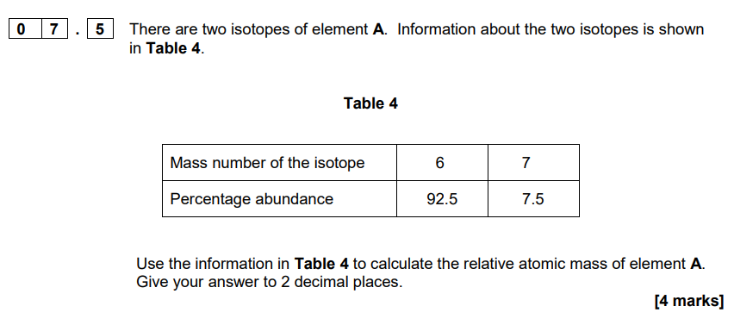

Mark scheme

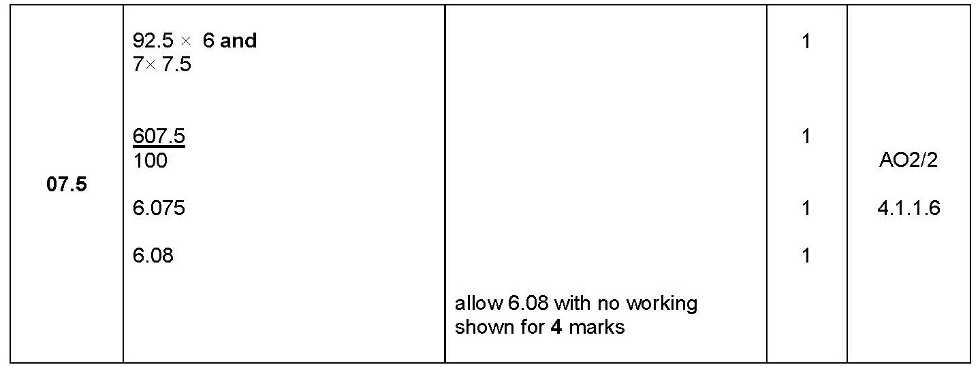

Example 8

Q7.6, GCSE Combined Science: Synergy 2F, June 2019

This question is set at Standard demand – students need to use the values from the table to calculate the mean and round their answer down to 4 significant figures.

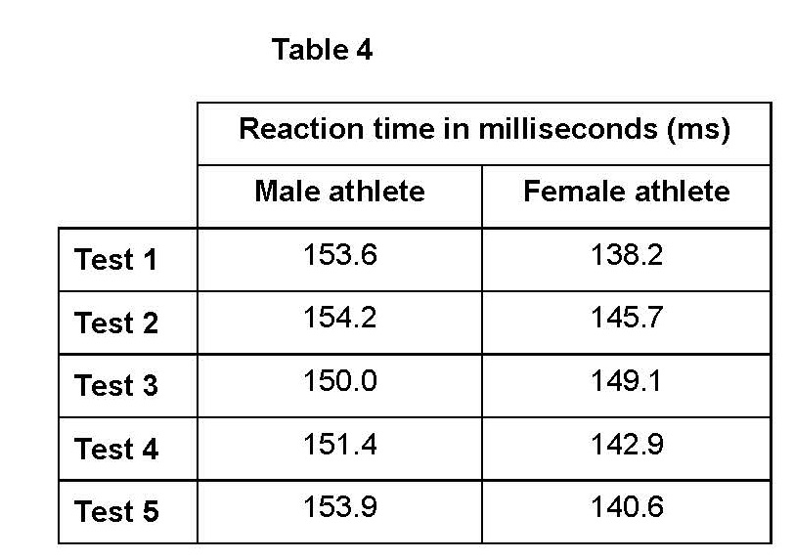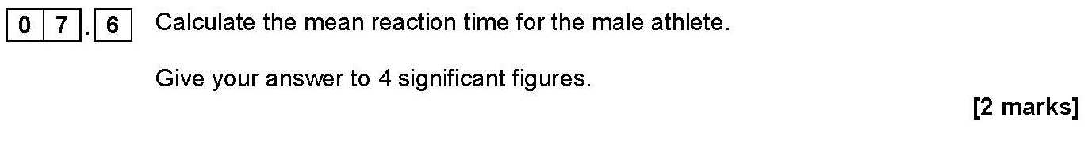

Mark scheme

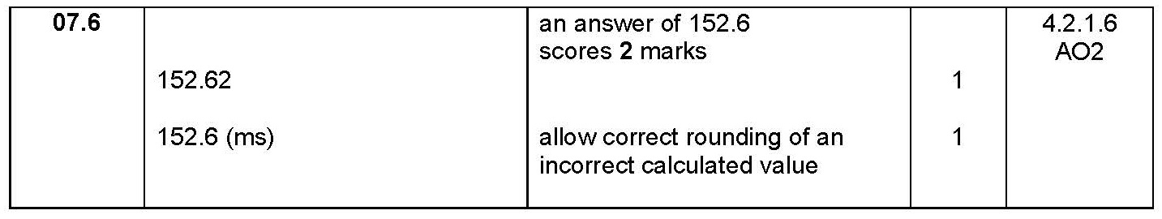

Example 9

Q5.2, GCSE Combined Science: Synergy 4H, June 2019

In this High-demand question, students need to round their answer up correctly to 3 significant figures.

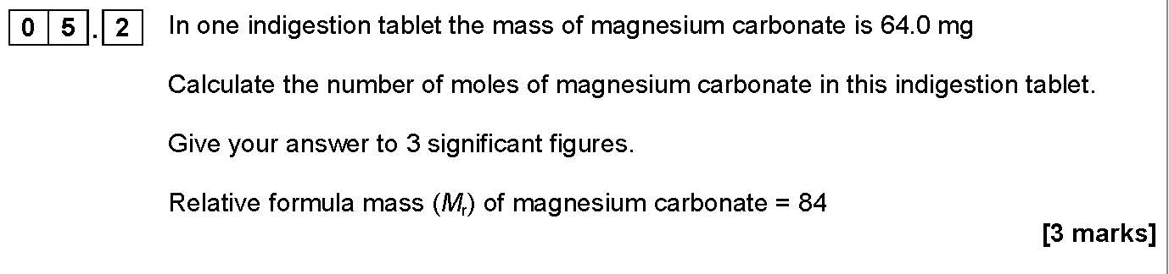

Mark scheme

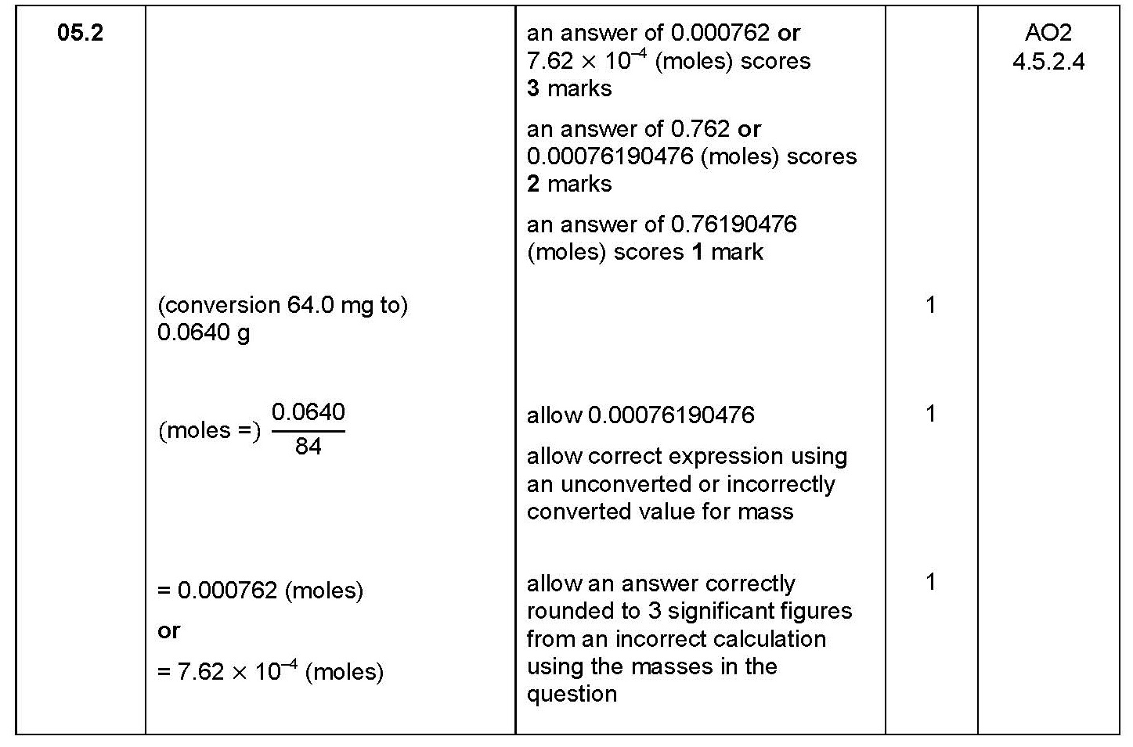

Examples from AS science

The A-level sciences subject criteria state that students may be tested on their ability to:
- report calculations to an appropriate number of significant figures given raw data quoted to varying numbers of significant figures
- understand that calculated results can only be reported to the limits of the least accurate measurement.

Example 10

Q2.1, AS Chemistry Paper 1, June 2018

Students are instructed to give their answer to a specified number of significant figures. Compare the demand with that in Example 8 – the numbers are, however, more challenging as they involve calculation using standard form.

Mark scheme

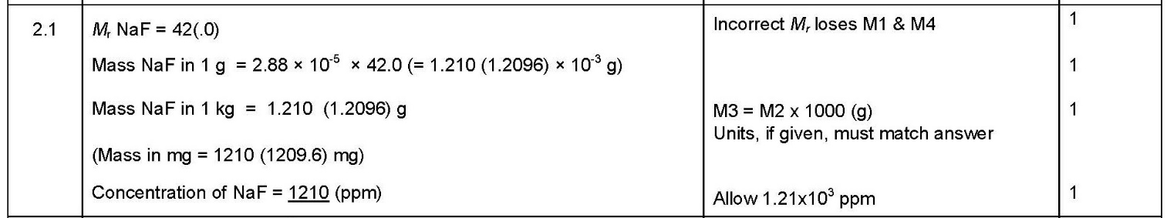

Example 11

Q7.4, AS Chemistry Paper 1, 2018

Further on in AS papers, the number of significant figures to use is no longer stated: students are simply instructed to use ‘an appropriate number of significant figures’. This is a step up in demand from the GCSE Higher demand question in Example 9, and matches the additional Foundation content of GCSE maths.

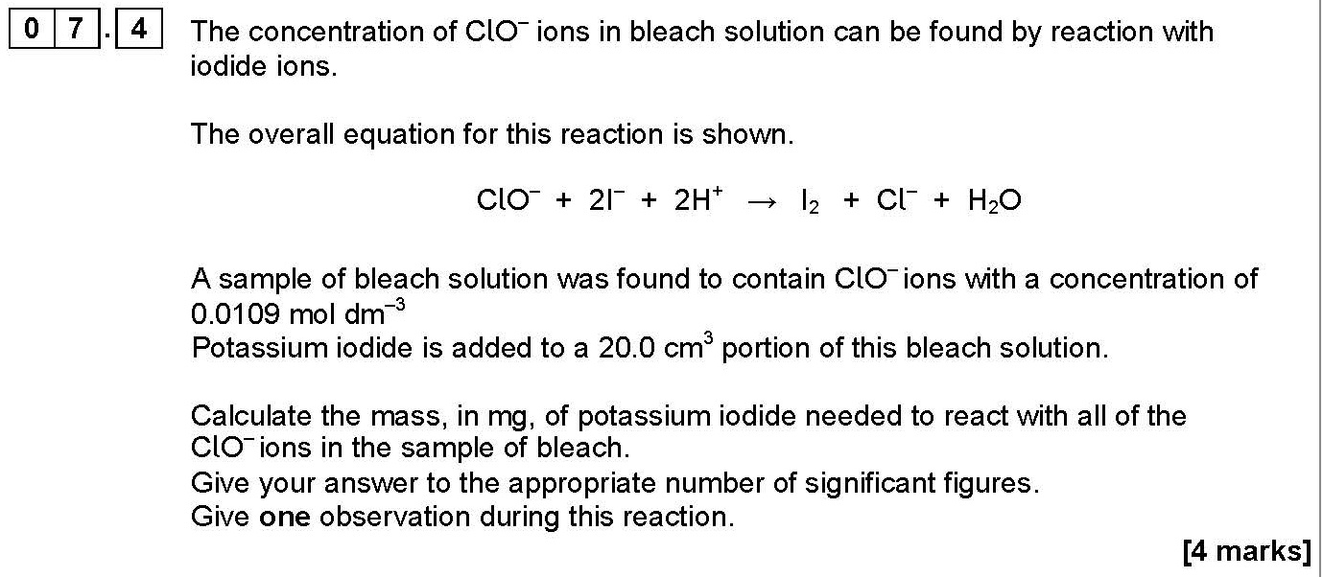

Mark scheme

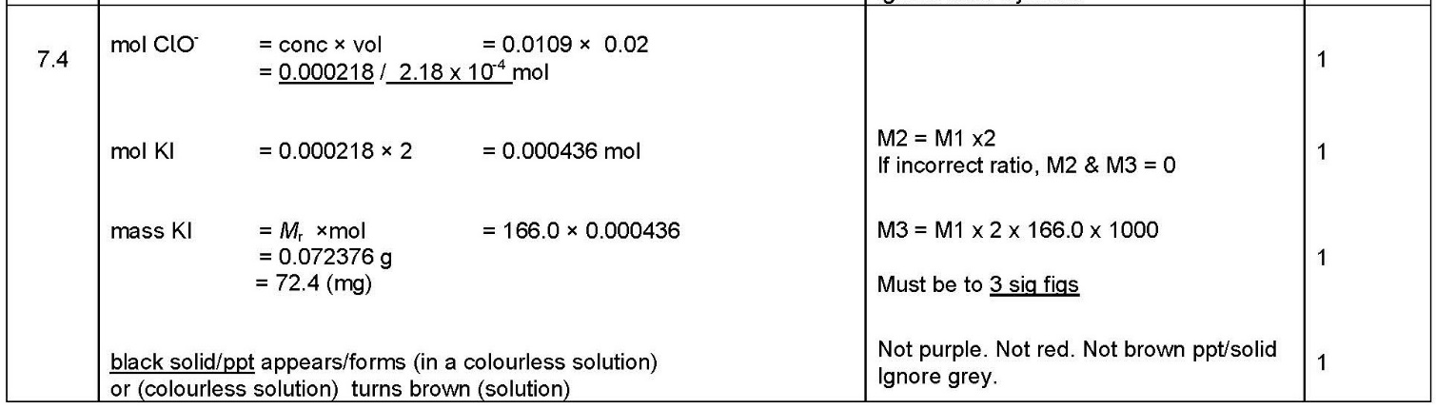

Rearranging equations

From the programme of study for KS3 maths
Pupils should be taught to:
- substitute numerical values into formulae and expressions, including scientific formulae
- understand and use standard mathematical formulae; rearrange formulae to change the subject

From the GCSE Maths subject criteria (Foundation; no extra criteria for Higher tier)
- A2 substitute numerical values into formulae and expressions, including scientific formulae
- A5 understand and use standard mathematical formulae; rearrange formulae to change the subject

From the GCSE science maths criteria
- 3b change the subject of an equation
- 3c substitute numerical values into algebraic equations using appropriate units for physical quantities

From the A-level science maths criteria
- 2.2 change the subject of an equation
- 2.3 substitute numerical values into algebraic equations using appropriate units for physical quantities

Remember that:
- On GCSE Foundation tier papers the level of maths must be: ‘not lower than that which is expected of Learners at Key Stage 3, as outlined in the Department for Education’s document Mathematics programmes of study: key stage 3’
- On GCSE Higher tier papers the level of maths must be: ‘not lower than that of questions and tasks in assessments for the foundation tier in a GCSE Qualification in Mathematics’
- On GCE (AS and A-level) papers mathematical skills must be ‘at level 2 or above’ (ie equivalent to Higher tier GCSE mathematics or above).

National curriculum in England: mathematics programme of study - Key Stage 3 Used under the Open Government Licence v3.0.

GCSE Subject Level Conditions and Requirements for Combined Science (2021) and GCE Subject Level Conditions and Requirements for Science. Used under the Open Government Licence v3.0.

Example from Key Stage 3 science Exampro question bank

In this sequence of questions students are tested on their ability to use the scientific equation

moment = force × distance

In the second and third questions, students need to rearrange this equation to calculate the answers.
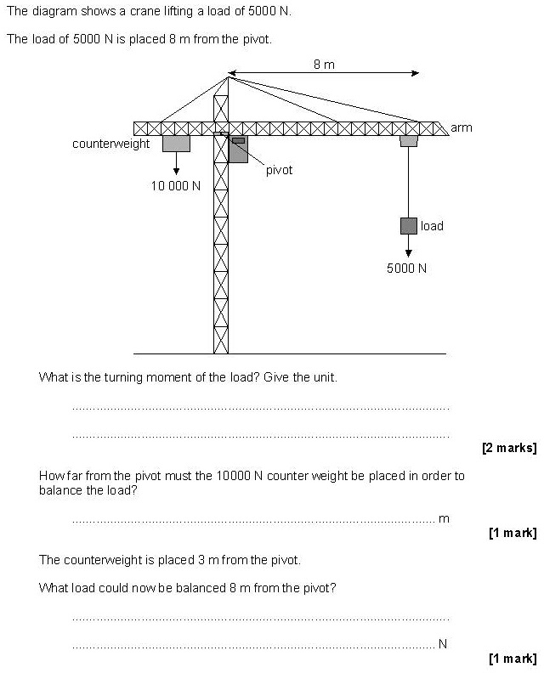

Examples from GCSE science

Progression of demand in GCSE assessments.

Low demand  (Foundation tier only) | Standard demand  (Foundation and Higher tier) | High demand  (Higher tier only)
In questions that require recall of equations from the ‘recall’ list students will be asked to identify a formula from a list. | Students will be expected to recall the equations from the ‘recall’ list. They will be prompted to do so (eg ‘write down the equation which links mass (m), momentum (ρ) and velocity (v) | Students will be expected to recall the equations from the ‘recall’ list without prompting.
In questions where students need to apply an equation, the equation will be given in the body of the question. | In questions where students need to apply an equation they will be prompted to recall the equation in an earlier part of the question. | In questions where students need to apply an equation they will be expected to recall or choose the correct formula without prompting.
Application will involve simple substitution with numbers that are easy to manipulate. Students may be asked to carry out a simple unit conversion | Application will involve substitution with something ‘extra’ such as transformation, changing a quantity, obtaining data from a graph or selecting appropriate data to use. | Application will also involve transformation, use of more complex equations, or multi-step calculations with no lead in or guidance given.
Students will not be expected to rearrange equations. | Students will be expected to be able to rearrange equations. | Students will be expected to be able to rearrange even complex equations.

Example 12

Q1.5, GCSE Combined Science: Trilogy Physics 1F, 2019

Low-demand question: students are simply required to substitute the numbers given into the equation, matching both the Key Stage 3 and GCSE maths criteria.

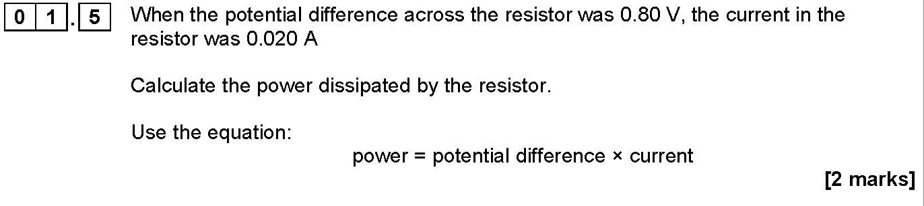Mark scheme

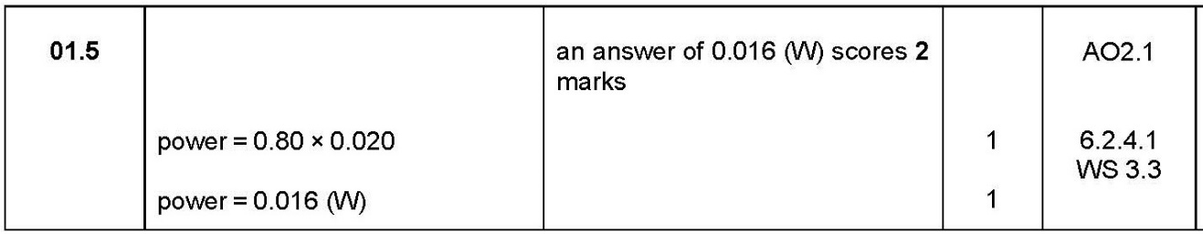

Example 13

Q4.3, GCSE Combined Science: Trilogy Biology 1F, 2019

This is also a Low-demand question: the equation to use is given and students need to substitute into it. There is a Low-demand ‘extra’ here, in that there is a simple unit conversion.

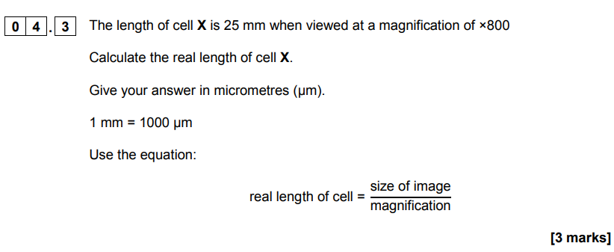

Mark scheme

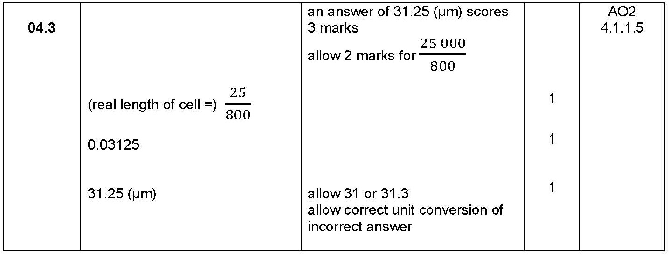

Example 14

Q6.6, GCSE Combined Science: Trilogy Physics 1F, 2019

Students need to substitute into the equation they recalled in the previous question (V = I R), then rearrange the equation to find R, all of which is Standard demand, and equivalent to the demand at Key Stage 3 and GCSE maths.

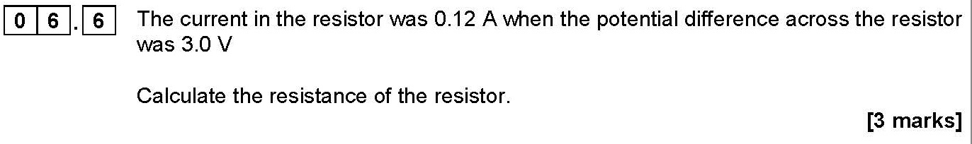

Mark scheme

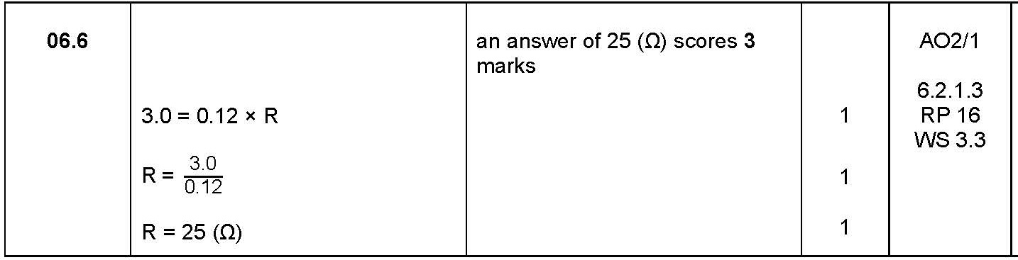

Example 15

Q8.4, GCSE Physics 1H, 2019

This is a High-demand question, in which students need to select and rearrange the equation
ΔE = m c Δθ in order to calculate the mass of an ice cube.

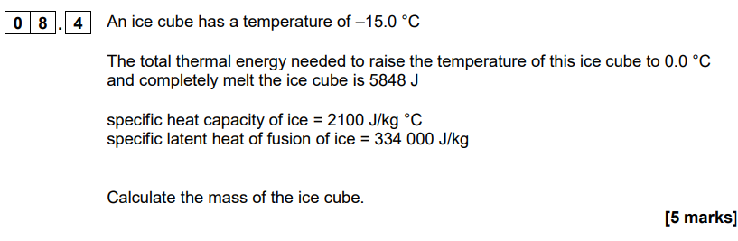

Mark scheme

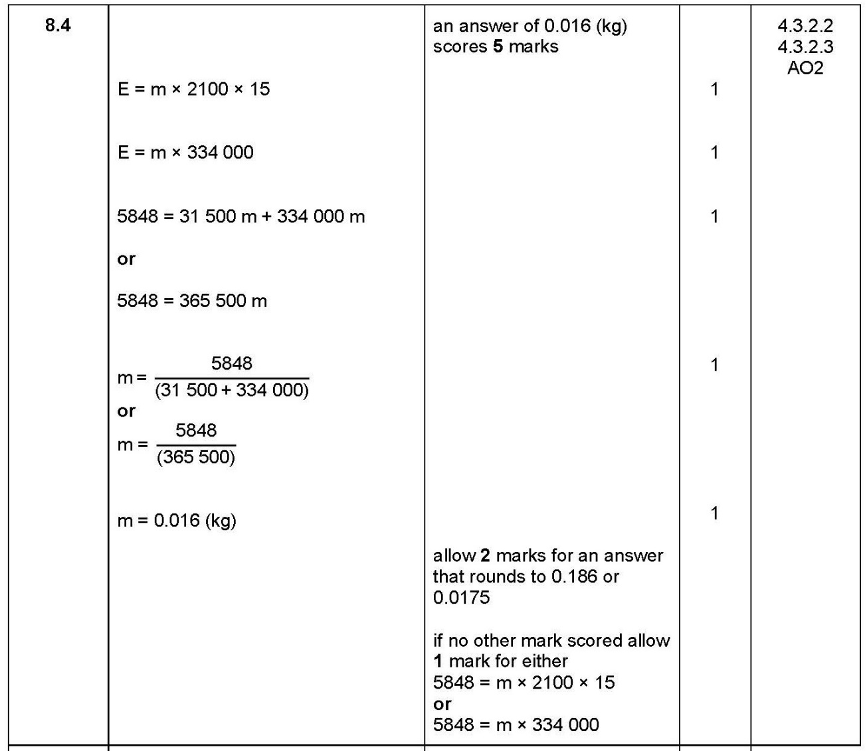

Examples from AS science

Students may be tested on their ability to use and manipulate equations, for example
- in Biology, magnification
- in Chemistry, structured and unstructured mole calculations (eg calculate a rate constant k from a rate equation)
- in Physics, rearrange E = m c² to make m the subject.

Example 16

Q3.2, AS Physics Paper 1, 2019

In this question, students need to rearrange the equation F = m a (given on the data sheet) to calculate the acceleration of the loaded cage. Compare the demand of the skill with that of Example 14, although the numbers are more challenging as they are given in standard form.

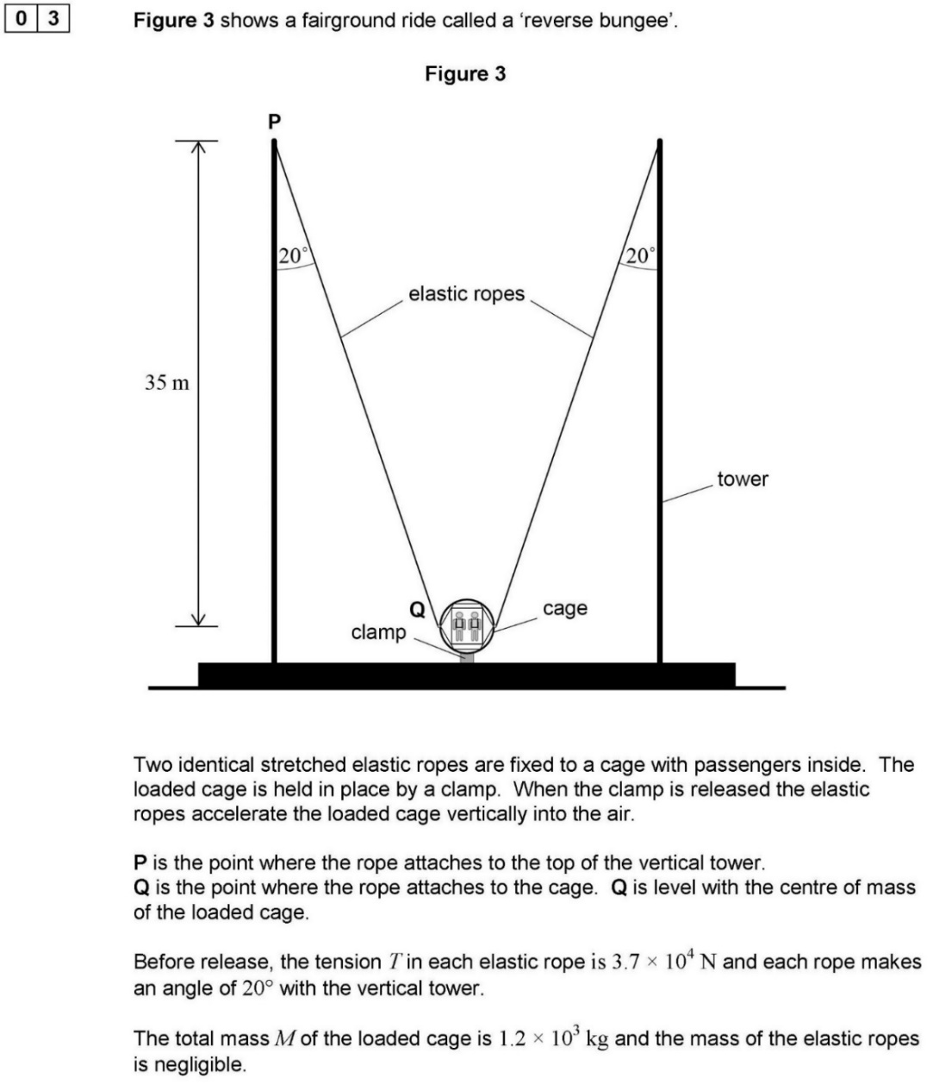

Mark scheme

Example 17

Q2.4, AS Chemistry Paper 1, June 2019

A multi-step calculation, in which students need to rearrange the equation given to determine the mass of 1 mole of germanium ions. Compare the demand of the skill with that in Example 15: again, the numbers are more challenging, using standard form.

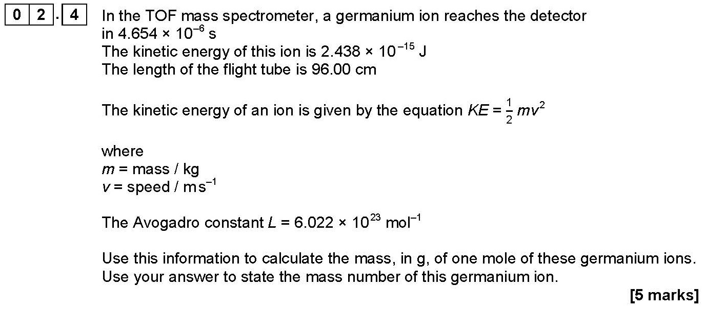

Mark scheme

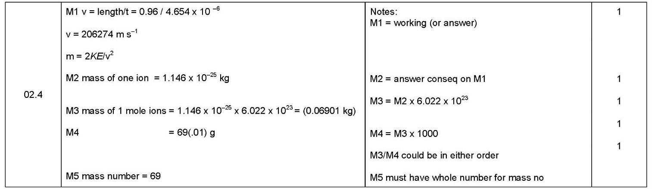

Notes
Contact us
Our friendly team will be happy to support you between 8am and 5pm, Monday to Friday.

Tel: 01483 477 756
Email: gcsescience@aqa.org.uk
Twitter: @AQA

aqa.org.uk

